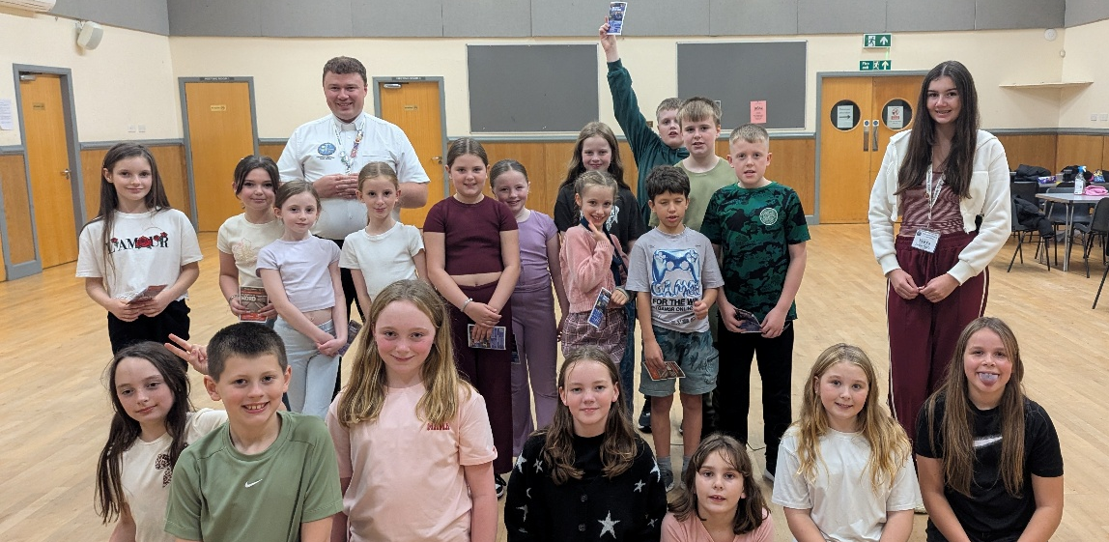

GALLOWAY YOUTH NEWSLETTER
OCTOBER 2026
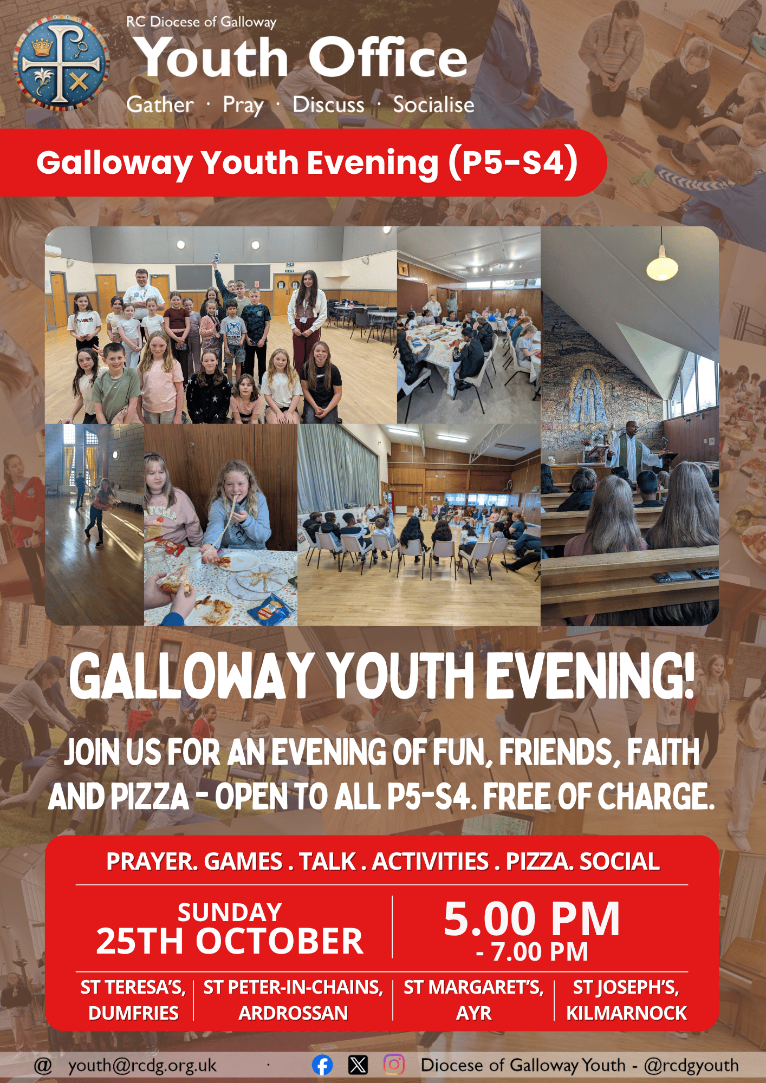
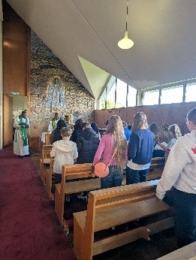
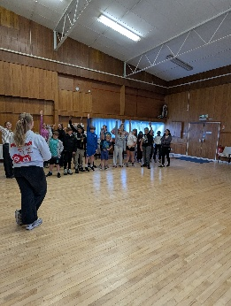
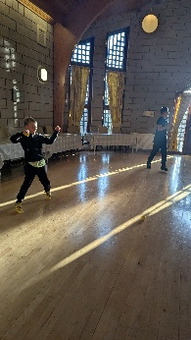
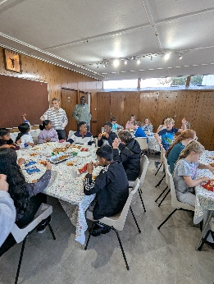
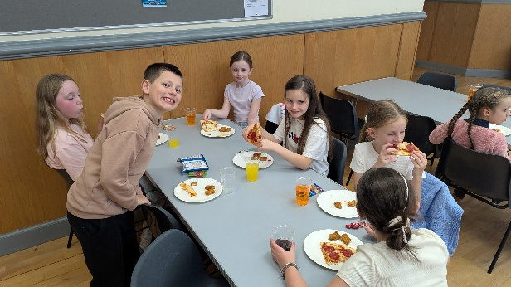
YOUTH EVENINGS RETURN: After a break over the summer our teams across the Diocese were delighted to start back with our monthly Youth Evenings in September! Across the Diocese we were delighted to welcome a record number of young people along, including regulars coming back after the summer, and lots of new faces as well with a fantastic number of young people keen to get involved! We’ve been receiving really positive feedback from families and schools with young people really excited to be back – and looking forward to our next evening this month! Remember, this month we’re a week later – Sunday 25th October – due to the school holidays. (Pictured above: Young people involved in the North Ayrshire evening, and below, a selection of photos from across the Diocese.)
Our next October Youth Evening takes place from 5.00 – 7.00 pm in: St Teresa’s, Dumfries; St Joseph’s, Kilmarnock;
St Margaret’s, Ayr; and St Peter-in-Chains, Ardrossan. This month, our evenings in Ayr and Ardrossan will begin with a short prayer service, while our evenings in Kilmarnock and Dumfries will begin with Mass as normal.
Coming up in November!
Register soon to secure your place!
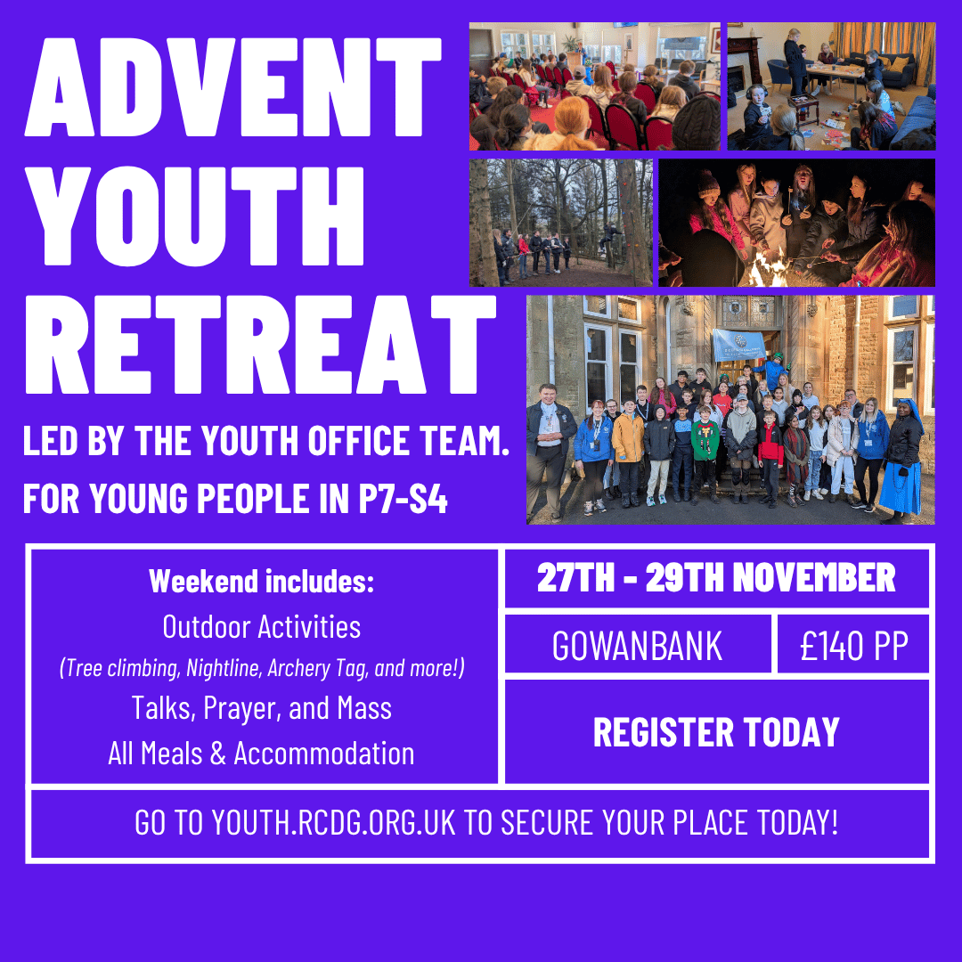

As usual, our Junior Leaders have a great selection of games and activities lined up which include favourites old and new to keep everyone entertained, as well as pizza, crisps, sweets and juice – all free of charge. Our short talk this month continues our series on the Mass and the young people will be talking about “The Liturgy of the Word” and understanding its importance as part of the Mass. Our Youth Evenings are completely free, so whether you’re new to Galloway Youth or a regular, what are you waiting for? We can’t wait to welcome you along! If you’re coming for the first time, please complete a general consent form by scanning the QR code on the right.
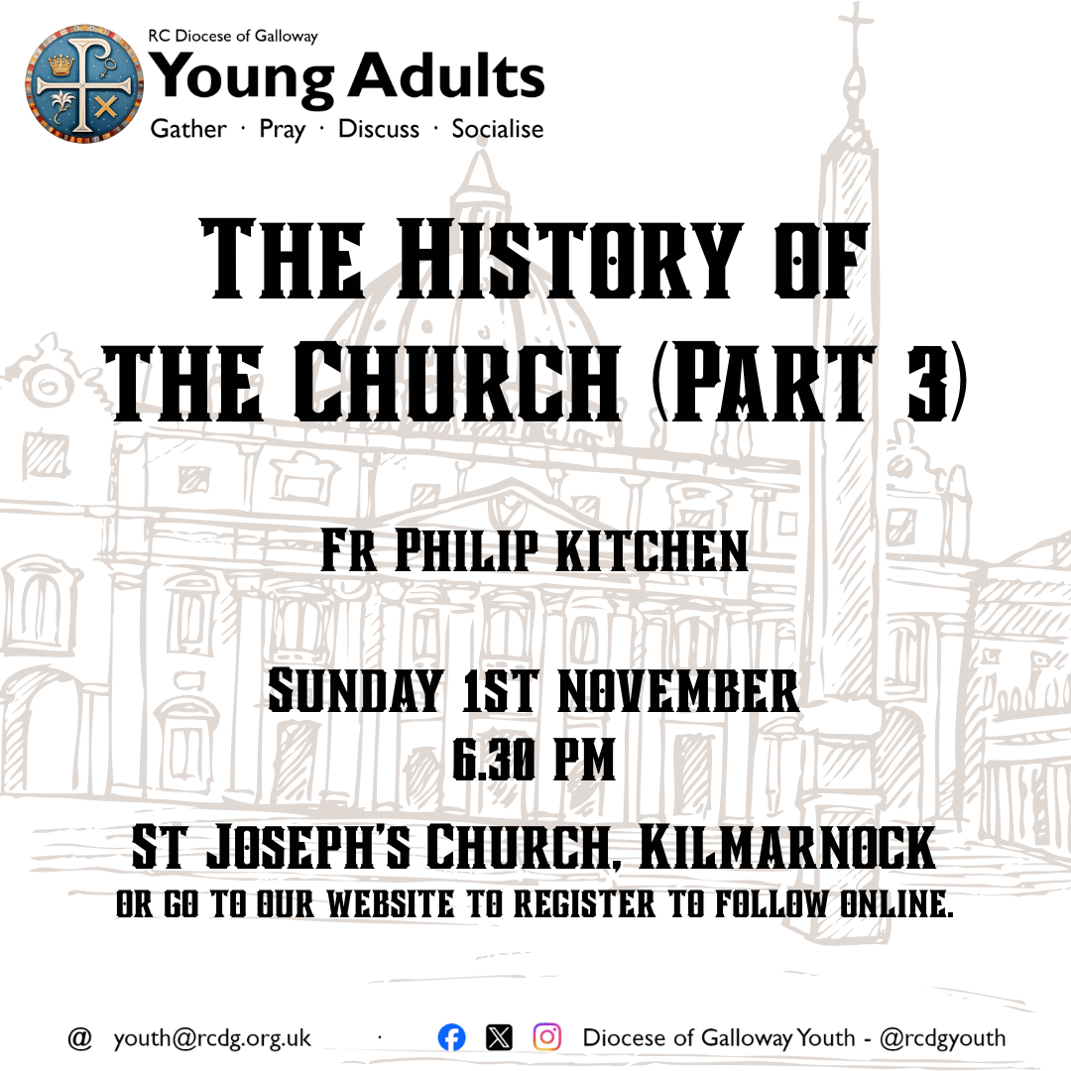
RESIDENTIAL EVENTS
Looking for something a bit different? Why not join us for one (or both) of our fantastic upcoming residentials!
ADVENT YOUTH RETREAT – NOW ONLY £140: LAST CALL – Register soon to secure your place for 2026! Join us for a weekend of outdoor activities, including: tree climbing, archery, archery tag; arts and crafts, silent disco and lots more! We’ll also have times of prayer and discussion on the theme of Advent, Mass, Reconciliation (Confession), and much more!
The retreat takes place at Gowanbank (near Darvel) from Friday 27th – Sunday 29th November. Free transport is provided from Dumfries and Kilmarnock, with leaders available to meet young people from the bus station as well if required. Young people will be in shared rooms with their friends/ young people of a similar age, with boys and girls in separate rooms.
The total cost for the weekend is £140.00, with funding available to support any young person in need or families with more than one young person taking part. For pictures from last year and to register, see our website.
2027 GALLOWAY’S SEOUL: In 2027, Pope Leo will gather with young people from around the world in Seoul, South Korea for World Youth Day. While we cannot travel there from Galloway, we look forward to following the events taking place in Seoul from Gowanbank as we take part in Galloway’s Seoul – a five-day celebration of World Youth Day taking place at Gowanbank.
From 7th – 11th August 2027, we’ll be taking over Gowanbank (near Darvel) to follow the events of World Youth Day. Each day will include: a time of Catechesis (faith learning) led by a visiting priest/ the Bishop, Mass, outdoor activities, including: canoeing, hillwalking, tree climbing, archery tag, and more; all meals, and times of prayer and discussion. The whole event is being organised and led by the Galloway Youth Office team and so young people will already know the leaders from other events.
We’re setting all young people a fundraising target of £400 per person. This covers all activities, meals, supervision, and transport (from Kilmarnock/ Dumfries). It’s open to anyone in P6–S5 this year (P7-S6 at the time of the event). We recognise that today the cost of living is expensive and so, to support young people in taking part, we have grants and bursaries available, as well as having bimonthly fundraising events. For full details, and to register, see our website.

AFTERNOON TEA
in aid of Galloway’s Seoul
Our young people can’t wait to take part in Galloway’s Seoul next year and are hard at work fundraising towards their £400 per person target – we’re grateful for any and all support received in supporting them to do this.

Join us in St Teresa’s, Dumfries on Saturday 31st October from 1.00 – 3.00 pm as we continue our fundraising for Galloway’s Seoul with an Afternoon Tea – and YOU’RE invited to join us! Tickets cost £10 and are available through the Youth Office website, as well as from St Teresa’s, Dumfries, from next weekend, and on the door. We will have a special prize available for one lucky ticket so make sure you get yours today! Donations of raffle prizes and home baking would be greatly appreciated. Why not bring your friends and family along for an enjoyable afternoon and help us to raise funds to support our young people as they prepare for Galloway’s Seoul! A free glass of Prosecco or juice will be served to everyone on arrival and we will have lots of tasty sandwiches and snacks. If you have specific dietary requirements, please email youth@rcdg.org.uk to let us know in advance.
SCAN THE QR CODE TO GET YOUR TICKET TODAY!

YOUNG ADULTS (S5-30)
PILGRIMAGE TO ROME: Please pray for 14 of our Young Adults who, led by Fr Kevin and Margaret, will be travelling on pilgrimage to Rome from 12th – 16th October. Be part of their pilgrimage by following online on our Facebook page @rcdgyouth.
YOUNG ADULTS’ EVENINGS: Our monthly Young Adults’ evenings continue on Sunday 1st November when Fr Philip Kitchen will be continuing his series on “The History of the Church”. Any young adults in S5 to age 30 are invited to join.
The evening takes place in St Joseph’s, Kilmarnock, and begins with Adoration at 6.00 pm following which Fr Philip will speak in the hall. Don’t live in East Ayrshire but want to take part? Online participation is available to any young adults from outside of East Ayrshire, to register to follow online, go to our website and click on ‘Young Adults – Online Participation’.

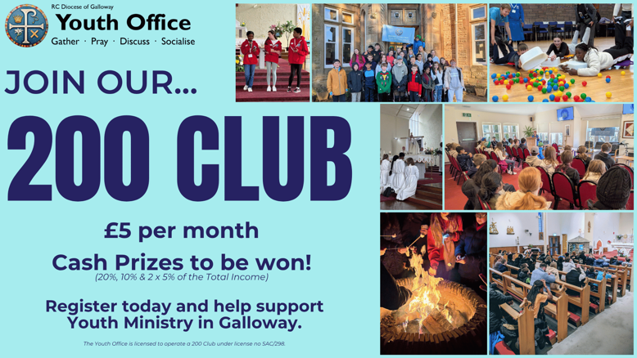
SUPPORT OUR WORK
JOIN THE 200 CLUB: Join the almost 60 members from across our Diocese and beyond who’ve already become part of the Youth Office 200 Club and help support our work while being in with a chance of winning cash prizes. For only £5 per month, you can join the Youth Office’s 200 Club and be in with a chance to win monthly cash prizes: 20%, 10% and 2 x 5% of that month’s draw. Funds from our 200 Club help to fund places for young people on our residentials who otherwise wouldn’t be able to take part. For details, and to register, go to: youth.rcdg.org.uk/200-club or email us for a registration form.
The winning numbers from the August draw: 1st – 42 2nd – 28,
3rd & 4th – 35 & 15. The winning numbers from the September draw: 1st – 48 2nd – 479 3rd & 4th – 56 & 44. All winners have been contacted.

