27th February 2026
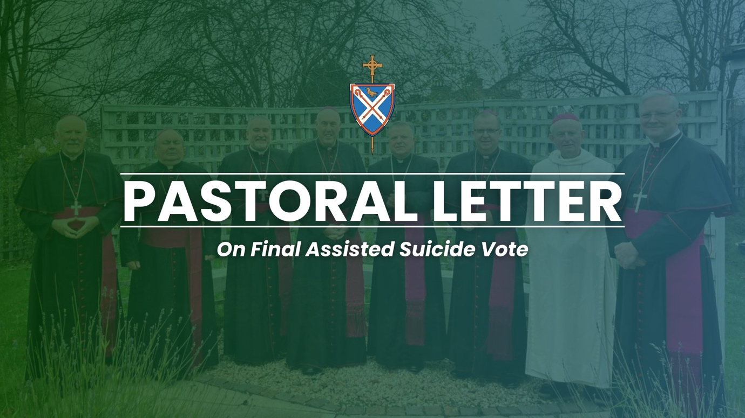

27 Choosing Compassion, Not Assisted Suicide - A Pastoral Letter from the Catholic Bishops of Scotland
Dear brothers and sisters in Christ,
Scotland stands at a moment of profound moral consequence. In the coming weeks, the Scottish Parliament will cast its final vote on the Assisted Dying for Terminally Ill Adults (Scotland) Bill; legislation that would, for the first time in our nation’s history, permit physician-assisted suicide. As your shepherds, entrusted with the care of souls and the protection of human dignity, we write to you with deep concern.
True compassion is not found in hastening death but in walking with those who suffer, ensuring they receive the medical, emotional, and spiritual care that affirms their inherent worth. Every person—regardless of age, illness, disability, or circumstance—is a gift from God. There is no such thing as a life without value. Our task as a society is not to eliminate suffering by eliminating the sufferer, but to surround every individual with love, support, and dignity until their natural end.
Over recent months, several Members of the Scottish Parliament who once supported the proposal have now either withdrawn, or are seriously considering withdrawing, their backing, recognising that the risks embedded within it are too grave to ignore. Their change of heart reflects a dawning awareness that coercion, especially the subtle, hidden coercion experienced by the most vulnerable, including the elderly, the sick, the disabled and those living with domestic abuse, cannot be reliably detected, let alone prevented.
Key protections that should form the very foundation of such legislation, however flawed the principle may be, have been removed or rejected. Proposals for mandatory training for doctors to recognise coercive control were voted down by the Parliament Health and Social Care Committee. Measures ensuring that patients are offered proper palliative and social care before considering assisted suicide were dismissed. An opt-out for hospices and care homes who object to assisted suicide was also rejected. Even the conscience rights of healthcare workers remain uncertain. As a result, MSPs are being asked to vote on a Bill that is incomplete and reliant on future intervention from Westminster—an arrangement that several parliamentarians have already described as unworkable and irresponsible.
Experience from abroad also offers a sober warning. In countries where assisted suicide has been introduced, narrow criteria have widened over time, placing ever more people at risk—not because of unbearable physical suffering, but because they feel abandoned, isolated, or burdensome. We must not allow such a trajectory to take root here in Scotland.
We therefore urge you, the Catholic faithful of Scotland, to act. Please contact your MSPs and respectfully ask them to oppose this legislation. Make your voice heard in defence of those who may not be able to speak for themselves. Resources to assist you—including Care Not Killing’s online email tool—are available and we invite you to use them prayerfully and thoughtfully.
Let us also hold in prayer all those approaching the end of life, all who care for them, and all charged with shaping the laws of our land. May the Holy Spirit grant our nation the wisdom to choose the path of life, compassion, and genuine human solidarity.
Yours devotedly in Christ,
+ John Keenan, President, Bishop of Paisley
+ Brian McGee, Vice-President, Bishop of Argyll and the Isles
+ Andrew McKenzie, Episcopal Secretary, Bishop of Dunkeld
+ Leo Cushley, Archbishop of St Andrews and Edinburgh
+ William Nolan, Archbishop of Glasgow
+ Joseph Toal, Bishop of Motherwell
+ Hugh Gilbert, Bishop of Aberdeen
+ Francis Dougan, Bishop of Galloway
Contact:
Media Office
Bishops’ Conference of Scotland
64 Aitken Street, ML6 6LT
Tel: 01236 764061
Email: media@bcos.org.uk

