PPC November 2025 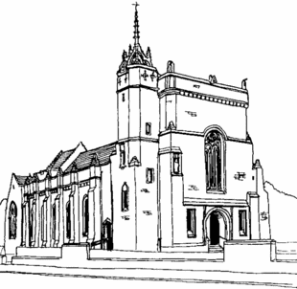
Meeting Minutes

[OFFICIAL]

Present (22):
Fr. Willie Boyd, Douglas Hutchison, Gail Taylor, Caroline Macdonald, Myra Carroll, John McConville, Tom Gilligan, Kathleen Hutchison, Andrew Johnston, Chris Denny, Hazel Mynard, Ann Hood, Hans Pieper, Janice Maxted, Helen Convery, Peter Convery, Pat Lee, Rona McAvenna, Ray Owens, Elizabeth Williams, Morag Bogle, Katie Schlesiger.

Apologies (11):
Suzanne Maxton, Liz Denny, Lindsay Young, Sadie Chalmers, Philippa Whitford, Gerard Smith, Carol Smith, Michelle Kelly, Fiona Hogg, Jaye McKeown,

Preliminary Date of Next Meeting: Monday 26th January 2026, 7pm

- Opening Prayer and Reflection: Gospel of the Day - Gail Taylor

- Introduction and Welcome - Douglas Hutchison

- Minutes and Matters Arising - Douglas Hutchison

- Guest Speaker - Katie Sclesiger - Head Teacher, Queen Margaret Academy
- Only 40 pupils short of school being at full capacity
- S1, S2, S4 are full (S3 minimal capacity)
- 60% of children with one or more Additional Support Needs (ASN)
- 10%of children English is not first language
- First School in South Ayrshire to be awarded the Communication Schools Award for neurodiversity accessibility.

A question was asked about how Catholic does QMA feel? There are 32 primary schools represented in S2 as an example so not all Catholic Primary feeder schools. There are opportunities to be more explicit about our faith but difficulty lies in the number of retained places offered each year for Catholic children. Once those places are gone, all children are dealt with on a first come, first served basis. Primacy given to medical needs, followed by associated primary then baptismal cert. See Appendix 1 for further breakdown of presentation. We extend our thanks to Katie for coming to speak to us and we will consider how we, as a parish, can support the school moving forward.

- Updates from various groups

- RCIA - Kathleen Hutchison
Group meets every 3-4 weeks. Between 6 and 9 attendees currently. Feedback that once brought into the church, RCIA comes to an abrupt end. Agreed we will arrange a Post-Easter Ministries Open Day. We’ll think about how we can continue Adult Faith Development and relationship building after Pentecost.
ACTION: Gather people post-RCIA to get feedback on what's next.

- Fabric - John McConville
The Church
Installation of emergency lighting and illuminated fire escape signage was completed on 30th October as planned. Now that this work is complete, we need to introduce a process that ensures regular testing and recording of all tests.
The roof repair that was undertaken to prevent water ingress behind the Pulpit seems to have been successful but is being carefully monitored. Some re- decoration will be required in the near future.
We had a leak and an electrical fault in the Church heating system. This caused the Church to have no heating for 2/3 days last week. It was repaired on Friday 21 st November. However, we have been made aware that one of the two pumps on the system have failed and the other could fail at any time. We have therefore agreed to the replacement of both pumps and associated bellows at an approximate cost of £3,100. We have also asked for an
estimate to provide a thermostat or something similar to control the temperature in the Church.
The external floodlights continue to be a problem. The company who installed the lights have already been on site and are due to re-visit on Wednesday 26th November.
An electrician has looked at the light above the main entrance to the Church
but will require to re-visit and erect scaffolding.
A Fire Safety Policy and an Emergency Fire Action Plan continues to be
developed.

The Church House
The broadband connection to the Church, Church House and Hall continues to be problematic. Virgin Media repaired a fault which improved the WiFi signal in the house but has caused other issues in the Church. The WiFi signal in the Hall continues to be very poor. A review of the broadband provision in all three properties is underway. Some snagging painter work is required in the new Parish Archive and once this is complete all parish records will be moved back into the Archive Store.
A list of key holders is being compiled and all key holders will be invited to a training session on the alarm system to be delivered by Highlander Security. Alarm fobs will be issued at that time. Some locks have already been changed, where necessary, new keys have already been issued or will be soon.

The Church Hall
Installation of emergency lighting and illuminated fire escape signage was completed on 6 th November. Now that this work is complete, we need to introduce a process that ensures regular testing and recording of all tests.
The roof on the west side of the building continues to be problematic. A roofer has looked at the issue on several occasions. We continue to closely monitor the situation.
The two warm air gas boilers serving the Hall were serviced last week. We await the issue of the appropriate Gas Soundness Certificates. The issue with the WiFi signal continues to make it difficult to remotely control the heating in the Hall.
We have now met with two firms of Architects to ask for their fee proposal to act as our professional advisors in the refurbishment of the Hall. At this moment we still have three possible scenarios for refurbishment of the Hall, namely:
o A cheap and cheerful refurbishment of the existing building
o A more comprehensive refurbishment of the existing building
o An extension plus a more comprehensive refurbishment of the existing
building

The two architects we met had different approaches and very different and varied fee proposals. As a result we are setting up a meeting with two ‘friends’ of the Parish who will give us expert advice on how to engage an architect and which architect we should engage.
One other option that will be considered at that meeting is the possibility of entering into a ‘Design and Build’ arrangement with a building contractor. We shall keep the PPC updated on any developments. We also hope to speak a Planning Consultant who is a friend of Lesley
Mathieson. This is an extremely important consideration bearing in mind that the Church is a Grade A Listed building and the Church House is a Grade B Listed building. Whilst the Church Hall is not Listed in any way, nevertheless, any development in close proximity to a Listed Building must be undertaken carefully, sensitively and in accordance with current Planning Regulations.It is recommended that use of the Hall continues as is, namely to internal Parish groups who are sympathetic to the current situation.

The Gardens
The large Leylandii hedge that enclosed the House Garden has been removed and a substantial, double sided timber fence erected in its place. At the first opportunity we will paint the existing metal gate and look to introduce additional security measures along the top of the new fence.
We will be hiring a skip in the next two weeks to clear out the garage and other bits of garden debris.
The border that runs from the rear of the garage to the gate at St Meddans Street has been substantially cut back. Composted soil is being introduced and it is hoped that this border will be used by Janice Maxted to grow flowers for the altar in future years.
With the grass cutting season over we will drain the three machines and arrange servicing of them. Maintenance of the garden grounds is a huge undertaken and we desperately need more help, if anyone is interested in joining us, please speak to myself
or any of the other gardeners.
ACTION: John to prepare big headline spends and income for Parish. A list of requirements for Audio/Visual to be pulled together for quotes.

- Finance Committee - Morag Bogle

- Parish income year to date
Details below. Key takeaways are:
● Overall collection income up 23% based on prior year (to 31 October)
● Standing order income up by an average of £489 per month for September and October when compared to January to August figures. This shows the impact of the presentation on parish finances at the end of August.
● Cash collected average July to October £2,147 average (collection re-started in July). January to June averaged £990 therefore an increase of £1,156
● We are benefiting from the card machines which have raised £4,675 to 31/10 split £1,983 church and £2,692 building fund
● Generous £5k donation received in year

- Building Fund collection

● The second collection for the building fund was introduced on 18/19 October. To date, the following amounts have been collected:
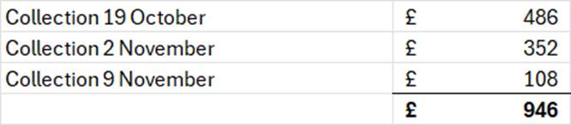
● The breakdown of amounts received in year are:

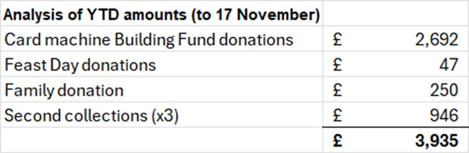

- Recent spend
Significant spend since my last report includes the following items:
- £8,543 annual insurance cost
- £5,400 installation of emergency lighting in the church
- £2,340 installation of emergency lighting in the hall

- Excess of expenditure over income of £1831 to 31 October.

ACTION: Morag to ask Carol to drop a note in the next bulletin regarding Gift Aid for Building Fund and Standing Order for Building Fund.

- Outreach - Gail Taylor

- Been out to 5 nursing homes in Troon
- We have c. 15 people interested in supporting outreach and all will need PVG.
- Two people will be assigned to each care home
- Feedback from both parishioners and staff has been positive
- Please let us know if someone is ill or housebound and we will add them to our list
- There is a joint venture with St. Ninians Episcopal Church for an Ecumenical Service at Queens View Harbour Facility.

- Christmas Arrangements - Fr. Willie

- Christmas Eve - Carol Service at 6.30pm and Mass at 7pm
- Christmas Day - Mass at 11.15am
- Pentitential Service - 8th December
- Advent Morning of reflection
- Please check bulletin in case of changes to dates/times
- Great response to the Night Before Christmas Campaign - many thanks.

- Liturgical Schedule - Douglas Hutchison

- See attached proposed schedule - Appendix 2
- Focus on Know, Grow and Show in September
- None of these activities can happen without laity volunteers
- Fr. Willie and Fr. Stephen Latham worked on a video so a session to be added to calendar for that
- We will support other parishes in Praying with Scripture
- Tea & Toast Christmas Special
- Ceilidh for HCPT in December
- ‘Smalls for All’ charity - link to be put in bulletin
- 80th celebration for Canon Keegans in Feb

- AOB and Date of Next Meeting

- Preliminary Date of Next Meeting: Monday 26th January 2026

- Proposed PPC Meeting Dates for 2026
  - Monday 26th January 2026
  - Thursday 26th March 2026
  - Monday 08th June 2026
  - Thursday 27th August 2026
  - Monday 05th October 2026
  - Thursday 26th November 2026

- Closing Prayer - Douglas Hutchison

Thanks to all who attended and for another lively discussion. We look forward to seeing you next time and welcome any new members.

Appendix 1

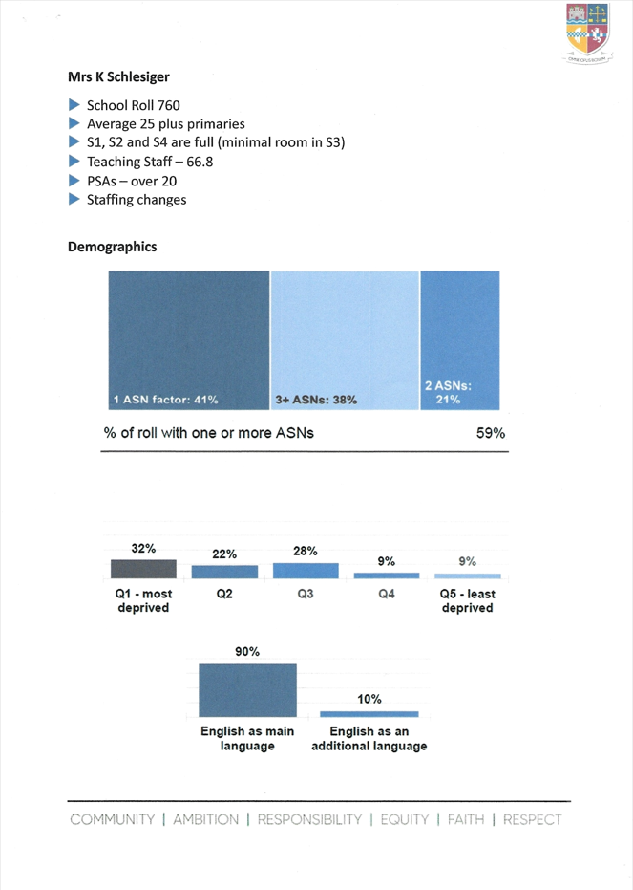

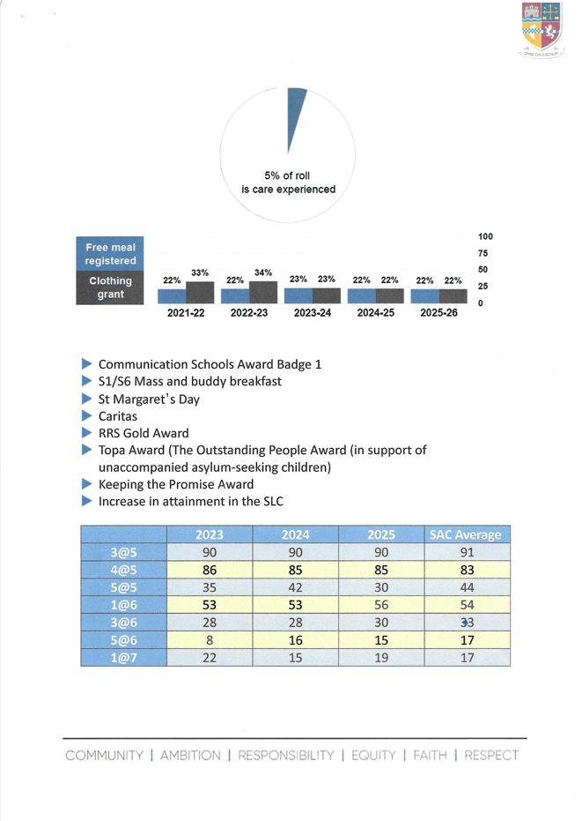

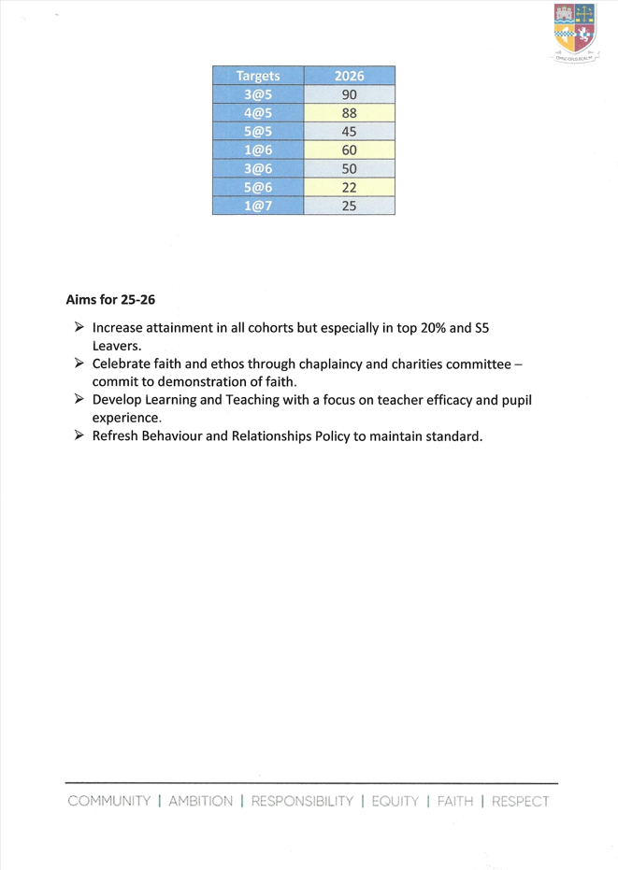

Appendix 2

