**Parish List**

**Why are we creating a Parish List?**

We belong to a parish because the Church wants to ensure Her members have a community in which and through which they can encounter Christ. An important part of that care is parishioners supporting parishioners. The Church is a community, and the parish is the most fundamental building block of that community. We are called to engage with our community, to get involved in helping in our parish but also to engage with our fellow parishioners. While the invisible bonds of a parish gathered in prayer and worship are real and powerful, it is better for everyone when those bonds are made visible by believers joined not just in prayer, but in community.

**What do I need to do?**

**Option 1:** Scan the QR code (open the camera on your phone, hold it over the code printed below and click the link when it appears) and complete the form.

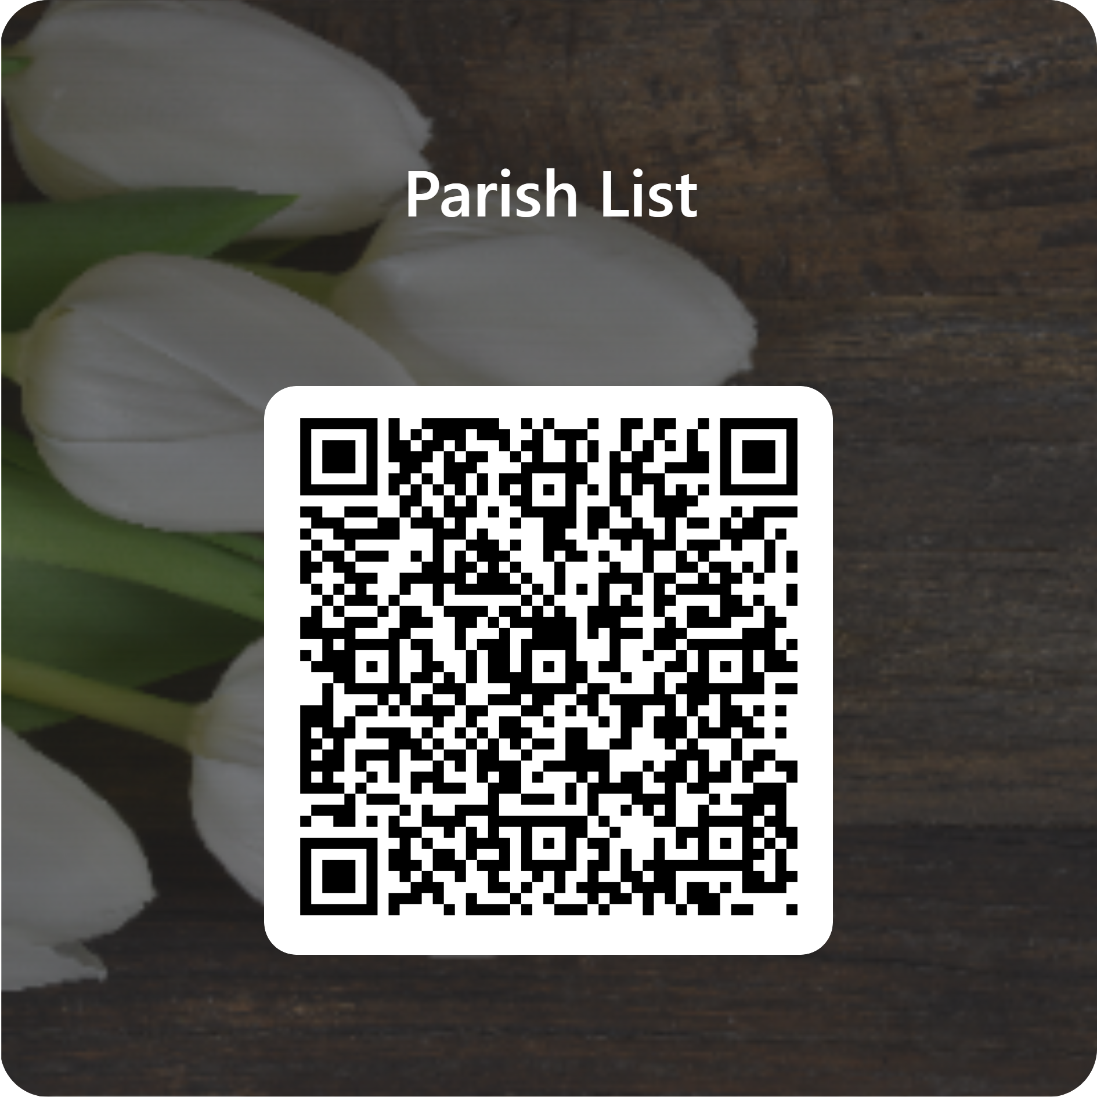

**Option 2:** Complete the paper form (in BLOCK CAPITALS) and pop it in the box at the back of the church.

**Option 3:** E-mail [ppc.secretary.troon@gmail.com](mailto:ppc.secretary.troon@gmail.com) with the information requested above.

Under the General Data Protection Regulation (GDPR) (EU) 2016/679, we have a legal duty to protect any information we collect from you. We will use your data for the sole purpose of creating a Parish List. Should you wish to amend your information or be removed from the list, please contact the Parish Pastoral Council Secretary by email. (ppc.secretary.troon@gmail.com)

**Parish List**

1. Name
2. Address
3. Date of Birth (dd/mm/yy)
4. Phone Number
5. Email Address
6. Named People in your household*, their denomination and date of birth

*Those living at the same address as you

|  |  |  |
| --- | --- | --- |
| Name | Denomination | Date of birth (dd/mm/yy) |
|  |  |  |
|  |  |  |
|  |  |  |
|  |  |  |
|  |  |  |
|  |  |  |
|  |  |  |
|  |  |  |

1. Are you related to anyone else in the parish? If so, please provide their name.
2. Are you aware of any sick or housebound parishioners?

We ask this in relation to offering Communion to the sick and Mass for the sick.