PPC October 2025 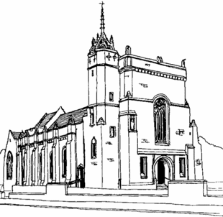
Meeting Minutes

[OFFICIAL]

Present (25):
Fr. Willie Boyd, Douglas Hutchison, Caroline Macdonald, Myra Carroll, John McConville, Sadie Chalmers, Tom Gilligan, Kathleen Hutchison, Andrew Johnston, Chris Denny, Hazel Mynard, Ann Hood, Philippa Whitford, Hans Pieper, Janice Maxted, Lindsay Young, Michelle Kelly, Gerard Smith, Carol Smith, Helen Convery, Peter Convery, Fiona Hogg, Jaye McKeown, JohnMcColgan, Anne Porter.

Apologies (11):
Gail Taylor, Suzanne Maxton, Patricia Lee, Liz Denny, Maria Brown, Rona McAvenna, Helen Javes, Lesley Mathieson, Claire Scott, Elizabeth Williams, Lindsay Young.

Preliminary Date of Next Meeting: Monday 24th November 2025 at 7pm

- Opening Prayer and Reflection: Gospel of the Day - Philippa Whitford

- Introduction and Welcome - Douglas Hutchison

- Minutes and Matters Arising - Douglas Hutchison

Ecuador Walk was successful. Thanks to those who prepared the teas & coffees afterward.

- Updates from various groups

- Finance Committee - John McColgan

Presentation on parish finances / hall
- This appears to have been well received. Thank you to many of you who have given feedback. Although a bit early to tell the ongoing impact of the discussion on reviewing standing orders (talk was on 30/31 st August, and most donate 1 st month), there have been 5 new standing order forms received and processed in September and an increase of £480 compared to the average figures from January to August. A similar number of Gift Aid declaration forms have also been received. Many thanks to all for their continued generosity and support.

Parish income year to date
Paper attached in Appendix. Key takeaways are:
- Overall income up 20% based on prior year.
- Standing order income up £480 in September (when compared to ytd average)
- Cash collected has settled at c.£1,800 in August and September. (Average year to June c.£1,000)
- We are benefiting from the card machines which have raised £4.424 ytd split £1,879 church and £2,544 building fund

Building Fund collection
- The second collection for the building fund will be taken up from 18/19 October. I shall report on income generated at the next meeting

Parish audit
- Delighted to report that the parish received a ‘no exceptions noted’ audit report from Azets.

- Fabric Committee - John McConville

- Fire Escape lighting due to be installed in the church w.c. 20th Oct for 3 days then w.c. 27th Oct for 3 days. Once this is complete, we will do the same in the hall.
- There was an issue with water getting in behind the pulpit. This has been repaired but some decorative work will have to be done.
- Awaiting report on Fire Extinguishers throughout church buildings
- Church house re-wiring is complete but this work interfered with the wi-fi. We only have one router servicing the church, house and hall.
- Loft conversion in the church house is almost complete.
- We had someone come to quote for an Intruder Alarm System. We now need to compile a comprehensive list of all key holders.
- The leaks in the roof have been repaired but a new one has appeared that will need repaired.
- Heating control in the hall needs fixed but this is dependent on a resolution with the wi-fi.
- We’ve continued to make progress with the refurb conversations and had an architecture firm out. A wish list has been created for them to review.
- Gardens - we’re getting to the end of grass cutting season. Janice is working on flower beds so we can use cut flowers for the altar flowers. Prep this year with benefit next year.
- Hoping to have another community garden afternoon for leaf raking.

- Youth Group - Fiona Hogg and Jaye McKeown

- Looking to plan another youth event (c. 7th December)
- Considering linking this to a charity. Initial thoughts are linking with ‘Night Before Christmas’. They may come and do a small talk and the kids could be the elves and help wrap the gifts.
- There were 13 kids at the Diocesan event so would be good to keep them engaged
- We could look to get kids involved in helping with the gardens as part of the ‘Laudato Si’ or ‘Pope Francis award’.
- Actively listening to what kids and parents are saying and helping to break down stereotypes and barriers for non-catholic families to feel included.
- Philippa added that the first Your Mass is scheduled for 8th November. Jaye and Fiona to send out comms to Youth Group.
- ACTION: Invite new QMA head teacher to a future PPC Meeting and Catholic Education Week.

- Tea & Toast - Sadie Chalmers

- Donated £400 to Macmillan Nurses - wonderful achievement
- Big thanks to all involved for a lovely morning.

- Confirmation - Douglas Hutchison and Fr. Willie

- We have been asked to consider the age of Confirmation
- After much discussion, Fr. Willie reiterated that there has been no groundswell of opinion that the age needs to change. Its a confirmation of Baptism and therefore should happen after Baptism and before First Communion so unless there is strong objection, we should leave it as-is.

- Praying with Scripture - Douglas Hutchison

- Oct-Dec - Meeting to go in the bulletin welcoming people to stay after teas & coffees. Those interested in leading a group should make themselves known.

- Adult Faith Formation - Douglas Hutchison
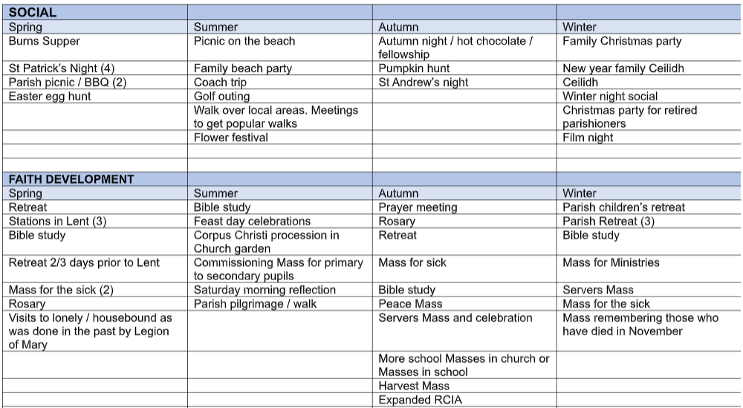

- Jaye and Fiona proposed a possible St. Patrick’s Day Race Night
- Gerard said if there was interest, we could do an Inter-Parish Golf Competition (e.g. our parish vs. St.Quivox)
- Hazel offered help for Hot Chocolate and Fellowship. Potential to combine with a Film Night.
- We discussed the potential for making some of these events fund raisers. The Ceilidh at New Year is a fund raiser for HCPT.
- Consideration given to Bible Study being 2-3 days prior to lent on a Saturday morning 9.30-12.30.
- Philippa suggested having not only a Mass for the Sick but also those who care for the sick.
- Caroline offered to help arrange a Servers Mass.
- Philippa suggested a Youth Retreat to Whithorn. It’s been done previously with camping.
- Agreed our demographic is the Facebook generation so we discussed having a post for parishioners to add more ideas and also volunteer to help with the events.
- John asked about the possibility of holding Taizé chants during Holy Week. Fr. Willie confirmed Holy Week is already a full calendar so would maybe be better in Lent.

- AOB and Date of Next Meeting

- We’ll have an RCIA update at the next meeting
- St.Annes Guild has 3 new members so now 35 in total. Invited other churches to get together for a Quiz.
- Fr.Willie asked for more volunteers for Prayers for Peace (07/10/25 10.30am to 3pm) as we need to create a safe environment for people. There were two spots still to be filled.

- Preliminary Date of Next Meeting: Monday 24th November

- Close - Douglas Hutchison

Thanks to all who attended and for another lively discussion. We look forward to seeing you next time and welcome any new members.

Appendix - Collection Analysis to 30/09/25

