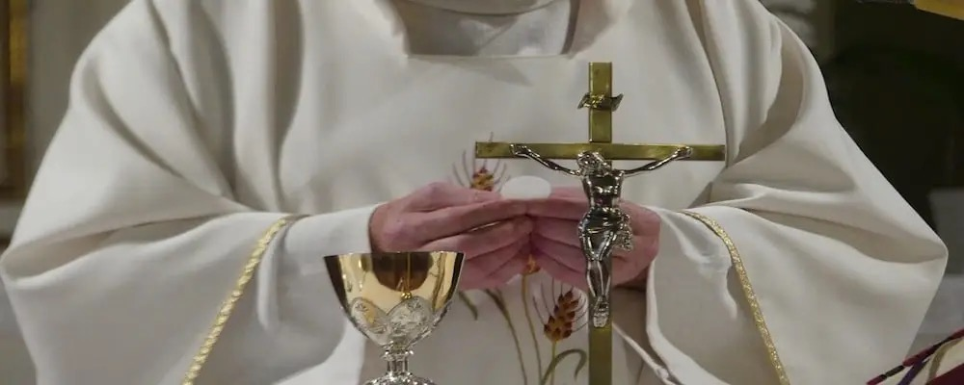
DO YOU FEEL CALLED TO DIOCESAN PRIESTHOOD? Do you sense a call to serve God and his people in the Priesthood? The Catholic Church in Scotland is inviting you to explore the possibility of a vocation to the priesthood. If you are considering a life dedicated to serving in the ministry, we encourage you to apply for seminary starting in 2027. To learn more about the application process and what a Priestly vocation entails, please contact the diocesan vocations director, Fr Stephen McGrattan on stephen.mcgrattan@rcdg.org.uk. The Vocations Director will support you in your journey of discernment and guide you through the steps along the way. Don’t hesitate; the Lord may be calling you to something extraordinary. Take the first step and contact the Diocesan Vocations director today!

