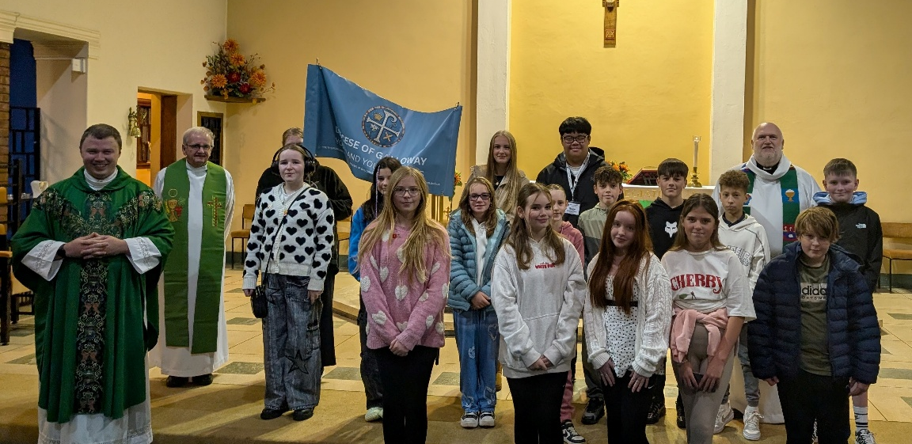
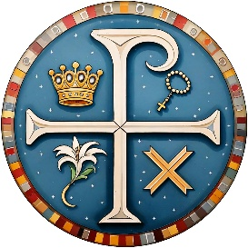
GALLOWAY YOUTH NEWSLETTER
NOVEMBER 2025

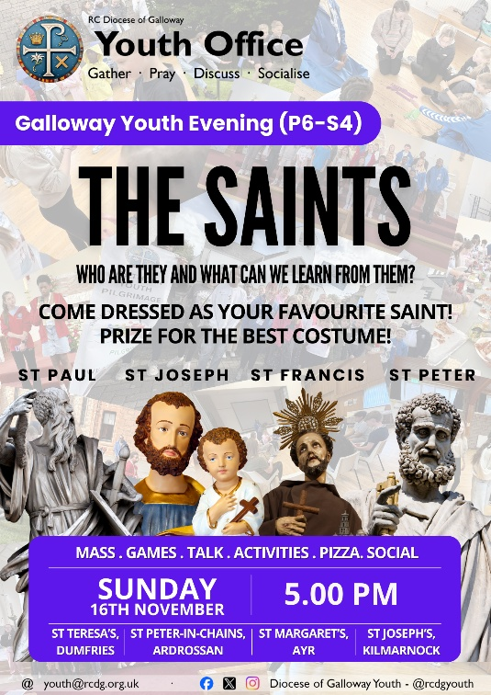
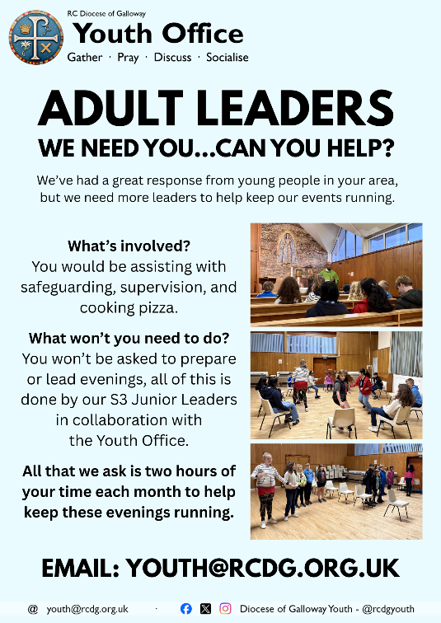
GALLOWAY YOUTH COMES TO THE ST MATTHEW’S ACADEMY CLUSTER!: On Sunday 26th October young people from across the St Matthew’s Academy cluster (North Ayrshire) gathered for the launch of our monthly Youth Evenings in North Ayrshire in St Peter-in-Chains, Ardrossan. The launch event saw 16 young people gather from across the cluster in spite of the poor weather. The group were supported by five new adult leaders from across North Ayrshire, and led by our new Junior Leaders from St Matthew’s Academy. During the course of the evening, the young people enjoyed exploring the question of Mary and her significance in their lives, as well as taking part in a wide range of different games and activities – some of our favourites, and a few new ones introduced by our new Junior Leaders. The next Youth Evenings take place on Sunday 16th November in all four clusters.
THE SAINTS: WHO ARE THEY AND WHAT CAN WE LEARN FROM THEM?: The next monthly Youth Evenings take place in all four clusters on Sunday 16th November. This month, young people will explore the theme of The Saints and their importance in our lives. Young people are invited to come dressed as their favourite saint, with a prize available for the best costume (please note, only costumes themed around the Saints are permitted). We’ll have our usual selection of games and activities led by our Junior Leaders centred around the theme of the Saints. The evening begins with Mass at 5.00 pm before continuing in the hall at 5.30 pm in all four clsuters. Haven’t been to a Youth Evening before? Fill in a Consent Form online, go to: youth.rcdg.org.uk. There is no charge to take part in the Youth Evenings.
ADVENT YOUTH RETREAT: Please note that the Advent Youth Retreat, taking place from 28th -30th November is now fully booked. We look forward to welcoming the 32 young people who have registered to take part along – don’t worry if you haven’t managed to register for this year, we’ll be repeating the retreat at a similar time next year. Keep an eye out in Lent for dates and early-bird registration.

GENERATION HOPE: Generation Hope is now in its forth year. Founded with a vision of helping young people in S1-S3 encounter Christ through time spent with friends in different outdoor activities, times of faith witness, prayer, Mass, and reflections. The week long summer camps have grown and gone from strength to strength – and now you can take part too if you are a Catholic and attend a non-Catholic secondary school. If you would be interested in attending camp alongside young people from all four Diocesan Catholic Secondary schools register your interest on our website: youth.rcdg.org.uk by Sunday 30th November. Subject to sufficient interest being received, we hope to work with the Education Authorities to seek permission to bring you to camp next year as part of the Galloway Youth group.
CHRISTMAS YOUTH DAY – SAVE THE DATE: Our Christmas Youth Day for P6-S4 takes place on Saturday 10th January from 11.00 am – 4.00 pm in St Joseph’s, Kilmarnock. Join us for a fantastic day of games, activities, talks and food as we gather to celebrate Christmas as Galloway Youth. Registration opens in late November.
ADULT LEADERS – WE NEED YOU: Our Youth Evenings have grown significantly in recent months in all four clusters, with 63 young people taking part in October, supported by 13 adult leaders with almost 30 now involved across the Diocese. To continue to support the running and growth of these groups particularly in St Andrew’s Deanery (Dumfries and Galloway) we need more adult leaders. What does an adult leader do? Our adult leaders are responsible for supervision, safeguarding, and cooking the pizza. You don’t have to prepare anything in advance, and you don’t have to run anything on the night – all of this is done by our S3 Junior Leaders supported by the Youth Office team. No experience is necessary, and full Safeguarding Training will be provided. All that we need you to do is to attend to supervise and to cook. Evenings normally take place from 5.00-7.00 pm on the third Sunday of each month. Could you help? Email youth@rcdg.org.uk for details and to register.
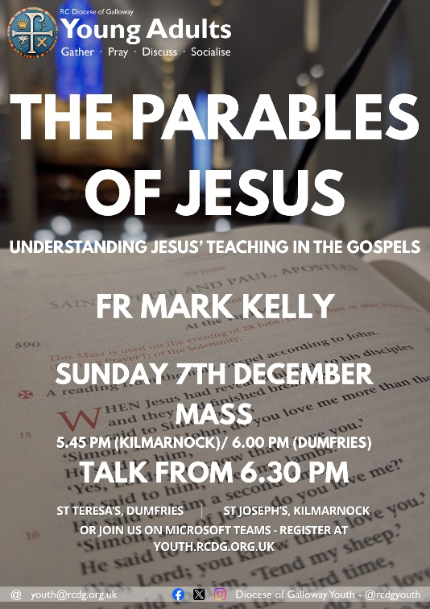

YOUNG ADULTS (S5-30)
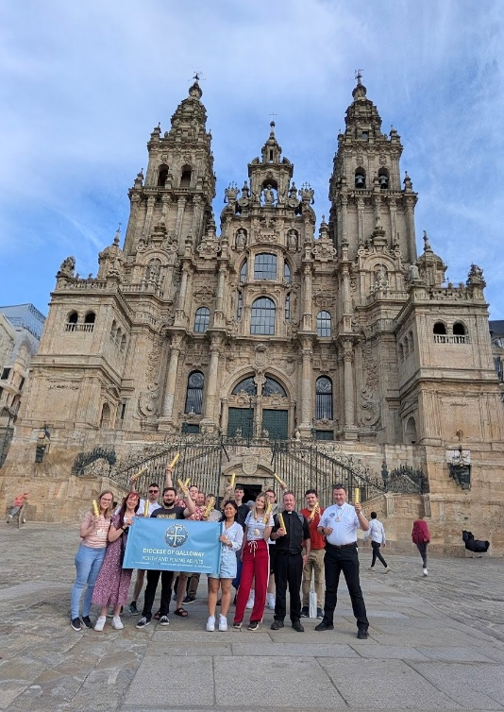
CAMINO DE SANTIAGO: Over 5 days in October, 11 young adults from the Diocese walked the final 115km of the Camino de Santiago. All of the group who set out walked through heat, blisters, and at times injury to complete the distance and walk into the Cathedral Square on Friday. It was a transformational and once in a lifetime experience for many of the group who took part. You can read all about it in the December edition of the Galloway Diocese News, or join us for an evening of presentation and discussion as the Young Adults themselves share their story.
CAMINO DE SANTIAGO: HEAR THEIR STORY: Join our Diocesan Young Adults for an evening of presentation and discussion they share their experience of walking the Camino de Santiago. The evening takes place on Friday 12th December at 7.00 pm in St Joseph’s Church Hall, Kilmarnock. There’s no charge for the evening, but donations towards the Young Adults’ pilgrimage fund are welcome. There will also be a bar and light food available.
THE PARABLES OF JESUS: Join Young Adults (S5-30) as they gather for their monthly evening in St Joseph’s Church, Kilmarnock and St Teresa’s Church, Dumfries. This month they’ll be joined by Fr Mark Kelly who’ll be speaking on ‘The Parables of Jesus: Understanding Jesus’ teaching in the Gospels. Whether you’re a regular or this would be your first time all are welcome to come along and take part. If you live outside of East Ayrshire or Dumfries you can now also join online via Microsoft Teams just to go youth.rcdg.org.uk and click on ‘Young Adults’ to register and we’ll send you a link each month to take part.
CHRISTMAS DINNER – SAVE THE DATE: The Young Adults Christmas Dinner will take place in St Joseph’s, Kilmarnock on Sunday 11th January. More details and registration opens soon, but save the date and come and join us. There’s no charge for this event.
SUPPORT OUR WORK

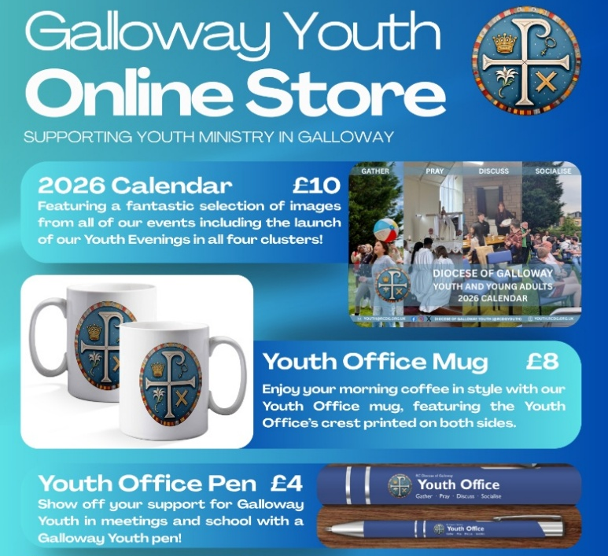
These products are available to everyone – not just those who’ve attended events or are youth/ young adults themselves –
and by buying Youth Office products you’re helping support our work.
GET READY FOR CHRISTMAS: with some fantastic stocking filers from the Youth Office! We’ve a range of items on sale from our online store including our 2026 Youth Office calendar, featuring a great selection of photos from our events in 2025, as well as a full calendar of dates for Youth and Young Adults events for 2026. These products are available to anyone – not just those who’ve attended events – and by buying Youth Office products you’re helping support our work.
BUY OUR CHRISTMAS CARD: available now, show your support for Youth ministry in Galloway by sending your friends and family a Youth Office Christmas Card this year. Cards are £1 each, or 6 for £5 with 41p from each card going towards supporting our work.
JOIN THE 200 CLUB: For only £5 per month you can join the Youth Office’s 200 Club and be in with a chance to winning monthly cash prizes: 20%, 10% and 2 x 5% of that month’s draw. Join the growing number of people from across the Diocese and beyond who are helping support our work, and taking home cash prizes at the same time. For details, and to register, go to: youth.rcdg.org.uk/200-club or email us for a registration form.
The winning numbers from the September draw: 1st – 7, 2nd – 4, 3rd & 4th – 16 & 10. All winners have been contacted.

