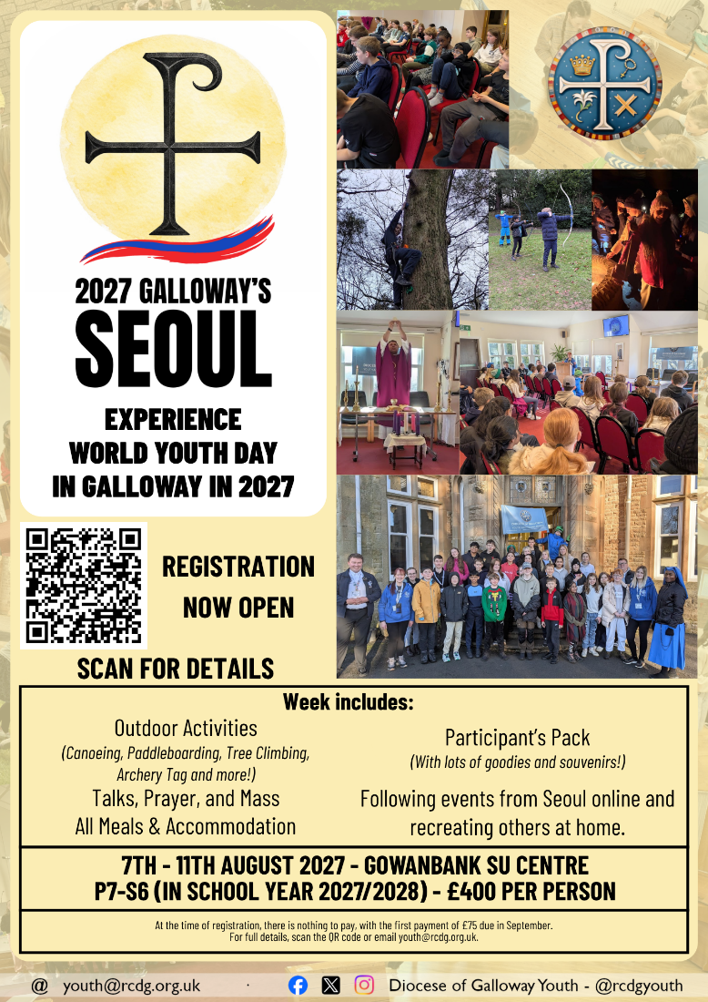
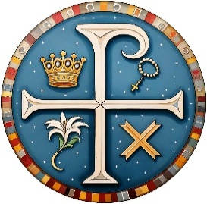
2027 GALLOWAY’S SEOUL
GALLOWAY YOUTH NEWSLETTER
MAY 2026


7th – 11th August 2027 - £400.
In 2027, Pope Leo will travel to Seoul, South Korea, for World Youth Day. While it isn’t possible for us to travel to join him, we’ll be following along and experiencing our own World Youth Day…Galloway’s Seoul. The five day camp will follow a similar programme to World Youth Day and include a talk each day (Sun – Tue) from a different speaker, Mass, following along with some of the gatherings in Seoul, while in the afternoons we’ll be enjoying the facilities offered by Gowanbank, with an extensive programme of outdoor activities both on and off site, as well as lots of breakout and chill out space. Young people will be accommodated on site in shared rooms with their friends and other young people of a similar age. All meals, activities, and resources are included in the cost, so there’s no additional cost to young people.
We have bursaries and grants available to support any families in need, or families with more than one child wishing to take part. We’ll also be carrying out fundraising with young people invited to take part to subsidise the cost of their place. When registering, there’s no deposit to pay, with the first payment of £75 due in September – but any funds raised will be credited towards this. For more details and to register, scan the QR code.

FIRST SPONSORED EVENT: Young people will be climbing Criffel, just outside Dumfries, on Saturday 13th June. They’ll cover a distance of 6-7 km, scaling a height of 569 meters. They’re now collecting sponsorship with all funds raised going towards their participation in Galloway’s Seoul. Would you like to make a donation to support a young person, or a general donation in support of their fundraising. Scan the QR code or visit our website to donate.
P4? CELEBRATING YOUR FIRST COMMUNION THIS YEAR?
SAVE THE DATE: SATURDAY 25TH JULY.
We’ve an exciting announcement coming just for YOU.
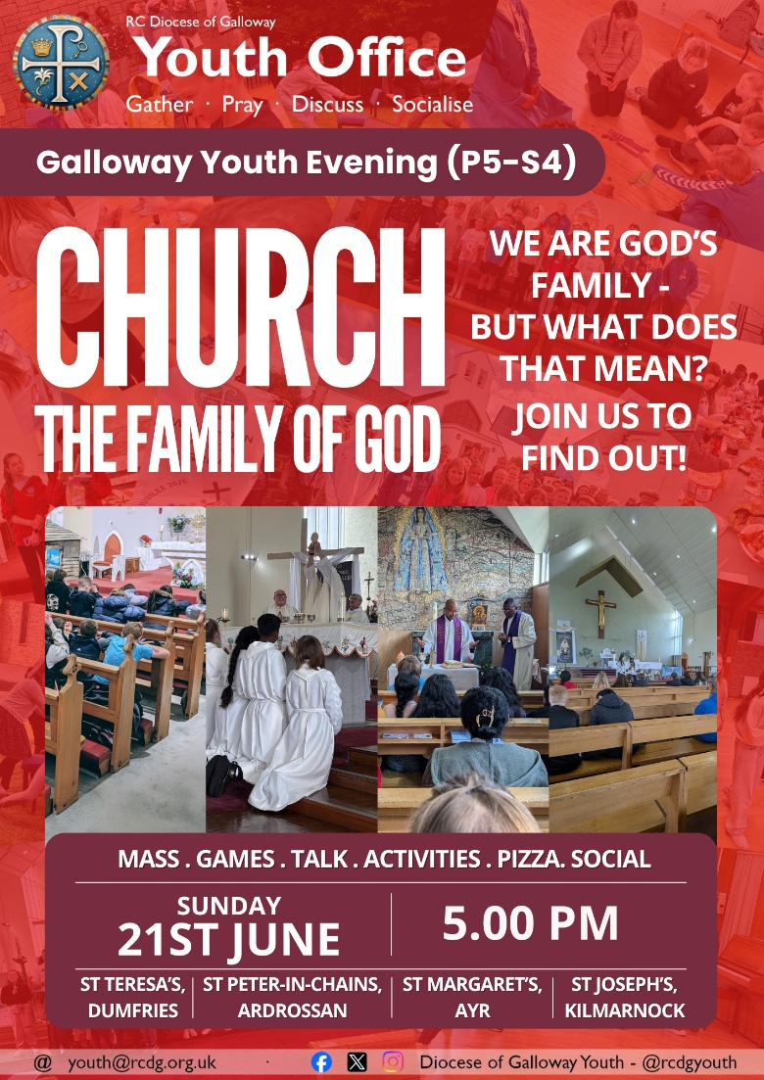
YOUTH EVENINGS: OPEN TO P5 UNTIL THE SUMMER! Our June Youth Evening takes place on Sunday 21st June in all four clusters: St Joseph’s Church, Kilmarnock; St Margaret’s Cathedral, Ayr; St Teresa’s, Dumfries; St Peter-in-Chains, Ardrossan.
For June, we’ll be thinking about the Church and understanding what it means to be part of God’s family. We’ll have our usual mix of games, activities, a short talk, and pizza! June is our final Youth Evening ahead of the summer holidays, but we’ve lots coming up over the summer to keep young people busy.
If you’re coming along for the first time (especially important for P5) please remember to fill in an Annual Consent Form online: youth.rcdg.org.uk.
2026 ADVENT YOUTH RETREAT
27th – 29th November 2026 - £160.

Join us for a weekend of activites, talks, prayer, reflection and friendship as we return to Gowanbank SU Centre for our 2026 Advent Retreat! Open to young people in P7-S4 (current P6-S3). The weekend costs £160, which includes everything: transport, food, accomodation, and activities! When registering, you’ll only be asked to pay a £50 deposit, with a further £50 due in June, and £60 in October.
GENERATION HOPE 2026: From 15th – 19th June over 100 young people from our four Diocesan Catholic secondaries will be taking part in Generation Hope, a 5-day summer camp for S1-S4. Please pray for them as they take part in this fantastic initiative, and follow their week online: @rcdgyouth.

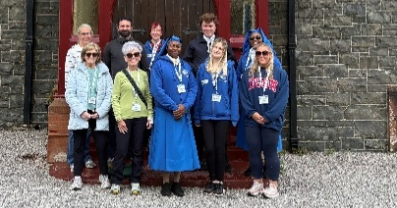
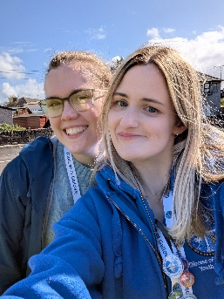
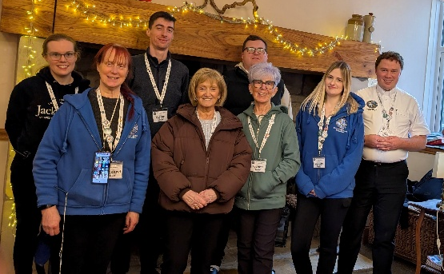
SPOTLIGHT ON VOLUNTEERS
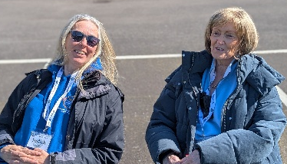
We have a fantastic team of over 30 volunteers who facilitate all of our events across the Diocese, from our monthly evenings, to our Diocesan Gatherings, to our residentials. These volunteers come from a wide range of backgrounds and experiences, but all give of their time freely to support our work in supporting young people in growing in faith and friendship with one another.
They fulfil a range of different roles including supervision, safeguarding, catering, and leading events – but as we continue to grow we’re appealing for more volunteers to join our team.
What’s involved? We know not everyone wants to lead an evening, but we have a number of different roles available – could you help out in the kitchen cooking the pizza? Even if you don’t want to lead evenings, by helping in the kitchen you can help our other leaders by freeing them up to work with the young people. Can’t make it every month? Don’t worry, the more volunteers we have, the less need there is to take part every month, and we’ll always work with you to support your involvement.
Want to get involved or find out more information? Email youth@rcdg.org.uk or check out our website.

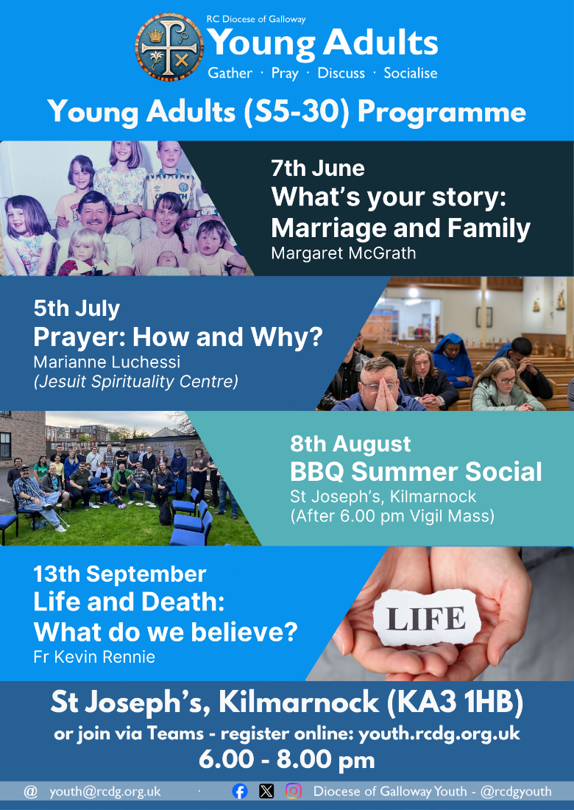
YOUNG ADULTS (S5-30)
YOUNG ADULTS’ EVENING: The next Young Adults evening takes place on Sunday 7th June in St Joseph’s Church, Kilmarnock. Margaret McGrath will be speaking on the theme of ‘What’s your story?’ as she shares her vocation story as a wife and mother. Mass will be celebrated at 6.00 pm, or you can come for the talk at 6.30 pm. Open to all young adults in S5 – age 30.
JULY YOUNG ADULTS’ EVENING: On Sunday 5th July, Marianne Luchessi from the Jesuit Spirituality Centre in Glasgow will be speaking on prayer: looking at various forms of prayer, how we pray, and taking the group through some practical examples of prayer. The evening begins with Mass at 6.00 pm.

ROME QUIZ NIGHT: Thank you to everyone who came along in support of the Rome Quiz night. Everyone had a fantastic evening and a total of £383 was raised in support of the pilgrimage fund. Keep an eye out for more fundraisers to come!
SUPPORT OUR WORK
JOIN OUR 200 CLUB!
Join the 40+ members who’ve already become part of the Youth Office 200 Club and help support our work while being in with a chance of winning cash prizes. For only £5 per month you can join the Youth Office’s 200 Club and be in with a chance to win monthly cash prizes: 20%, 10% and 2 x 5% of that month’s draw. Join the growing number of people from across the Diocese and beyond who are helping support our work, and taking home cash prizes at the same time. For details, and to register, go to: youth.rcdg.org.uk/200-club or email us for a registration form.
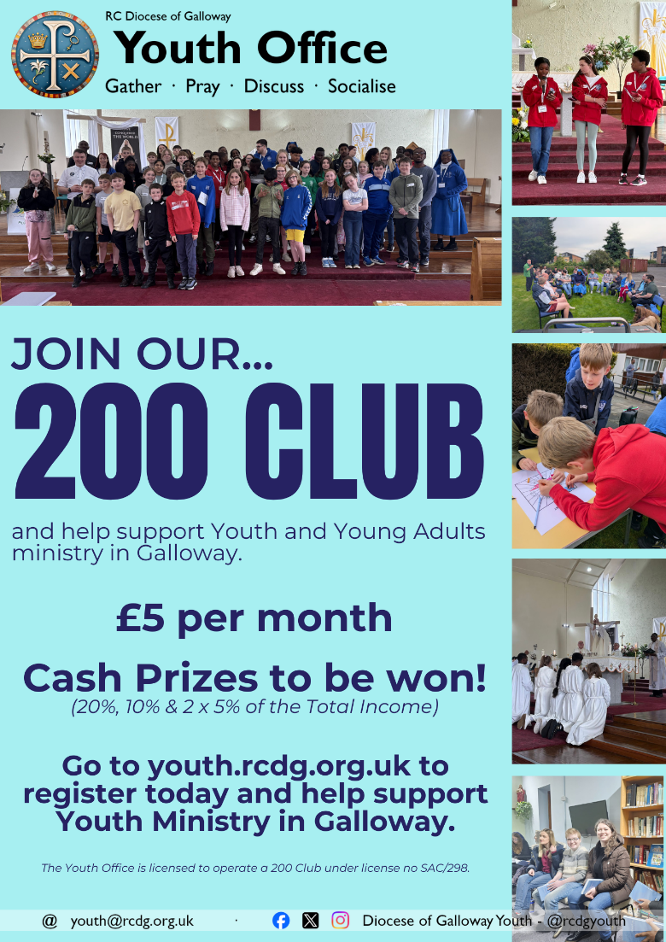
The winning numbers from the April draw: 1st – 41, 2nd – 12, 3rd & 4th – 10 & 22. All winners have been contacted.

