

GALLOWAY YOUTH NEWSLETTER
JANUARY 2026
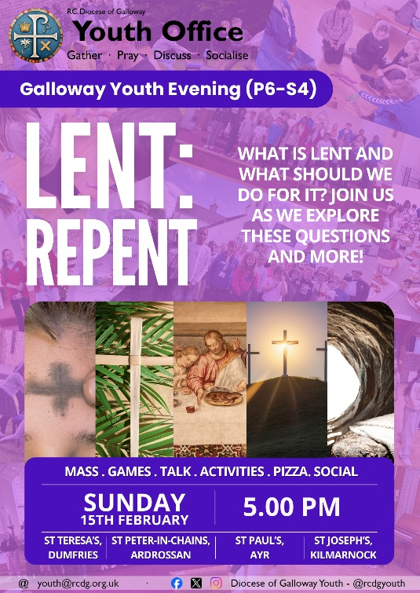
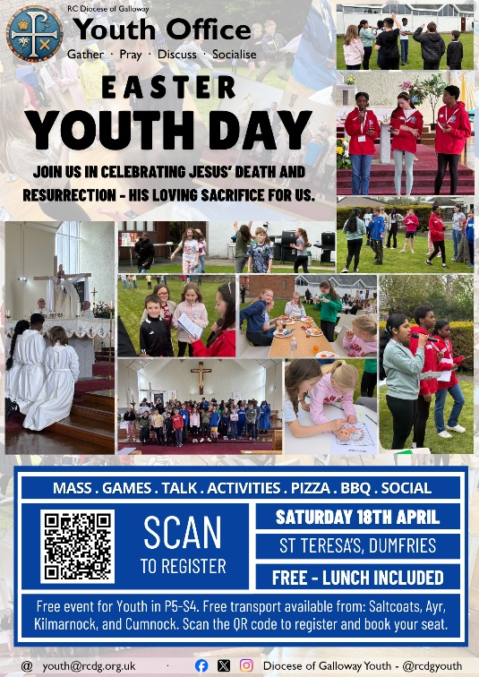
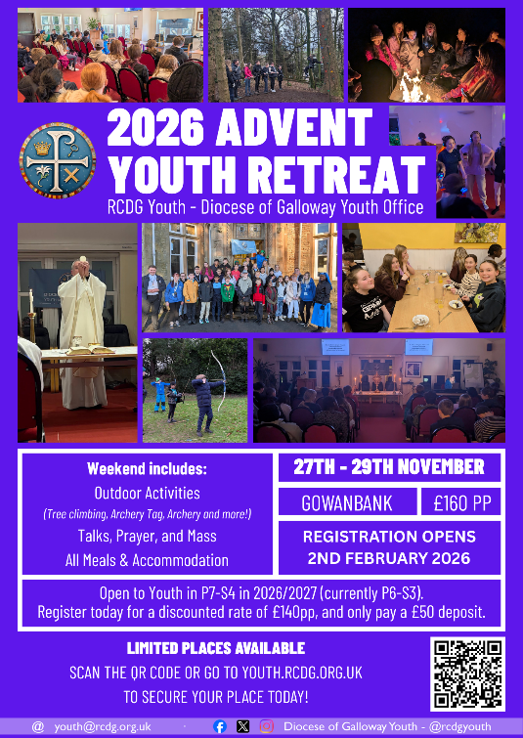
CHRISTMAS PARTY: On Saturday 10th January, thirty-eight young people from across the Diocese gathered in St Joseph’s Church, Kilmarnock, for their Christmas Party. During the day they spent some time hearing from our Junior Leader Mentors on the true meaning of Christmas as they reflected on the Nativity and Christmas as being not simply for presents but for peace, hope, joy, and love. In his homily for the Mass, Fr Kevin reminded them of Jesus’ love for each of them: that he knows them all by name and formed each of them individually in his image, and that he loves each of them perfectly. The young people also spent some time playing a range of different games, led by our Junior Leaders throughout the day as they spent time celebrating Christmas and getting to know one another – a favourite game being Human Hungry Hippos! Check out our Facebook page for lots of photos from the day, and join us for our next events in February to be in the photos and to be part of the story!
YOUTH EVENINGS: We’ve no Youth Evening in January as the Christmas Party takes the place of it, but we look forward to resuming on Sunday 15th February from 5.00 – 7.00 pm in all four clusters:
- North Ayrshire – St Peter-in-Chains Church, Ardrossan
- South Ayrshire – St Paul’s Church, Ayr
- East Ayrshire – St Joseph’s Church, Kilmarnock
- Dumfries & Galloway – St Teresa’s Church, Dumfries
Please note: In February, South Ayrshire will meet in St Paul’s Church due to a conflicting event at the Cathedral.
In February, we’ll be reflecting on the theme of Lent as a time of preparation, and of course enjoying our usual range of games, activities and pizza as well. The evening begins with Mass at 5.00 pm before continuing in the hall.
Whether you’re a regular or it’s your first time we’d love to welcome you along, there’s no need to register but, if it’s your first time, we do need your parent/ carer to complete an Annual Consent Form on our website: youth.rcdg.org.uk.
We are extremely grateful to all of the Junior Leaders, Adult Leaders and clergy who support our evenings by leading the inputs, supervising, cooking pizza, and celebrating Mass – it wouldn’t be possible to do what we do without all of them.

WHAT’S ON GUIDE: There’s lots coming up over the next few months for young people in our Diocese, you can download your copy of our What’s On Guide free of charge from our website so that you never miss an event. It also includes a complete calendar for all of our events in 2026!
2026 ADVENT YOUTH RETREAT: Following the success of our 2025 Retreat, our 2026 Retreat will take place from 27th – 29th November. For 2026 we look forward to returning to Gowanbank Scripture Union Centre and welcoming along young people in P7-S4 (current P6-S3). The weekend costs £160 with an early bird discount to £140 if you register before Easter Sunday. When registering, you’ll only be asked to pay a £50 deposit, with a further £45 due in June, and £45 in October.
Registration opens on Monday 2nd February with places being allocated on a first come first served basis – so be sure to sign up early to guarantee your place!
EASTER YOUTH GATHERING: We may have only concluded our Christmas celebrations but we’re already getting ready for our next Diocesan Youth gathering – our Easter Youth Day! Join us in St Teresa’s, Dumfries as we gather for a day of games, activities, Mass and talks to celebrate Easter! This year, we’ll be reflecting on the Holy Spirit and how he works in our lives as part of the wider Diocesan Year of Prayer. Registration is now open – sign up on our website!

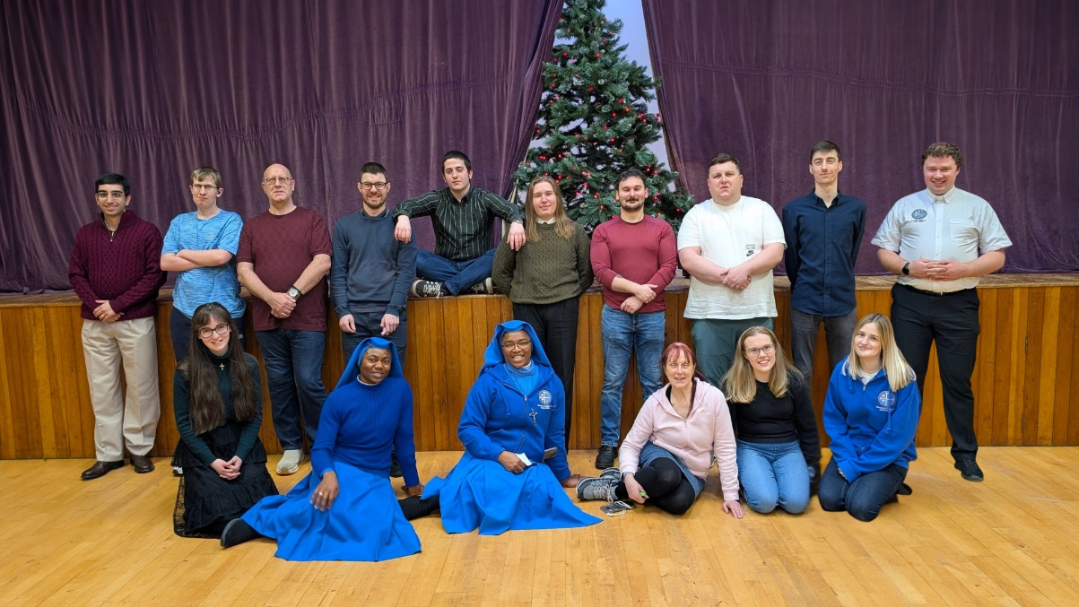
YOUNG ADULTS (S5-30)
YOUNG ADULTS CHRISTMAS DINNER: On Sunday 11th January, our Diocesan Young Adults enjoyed their Christmas Dinner at St Joseph’s Church, Kilmarnock. The group enjoyed catching up after the Christmas period and discussing the coming year and our plans for the year. Following the success of both the Summer BBQ and the Christmas Dinner, the group are planning more socials as well the monthly series of talks. The socials will take place in different places around the Diocese and will be open to all young adults – whether you’re a regular or a first timer. Our thanks to the catering team at St Joseph’s who prepared the meal, and to everyone who came along to enjoy it.
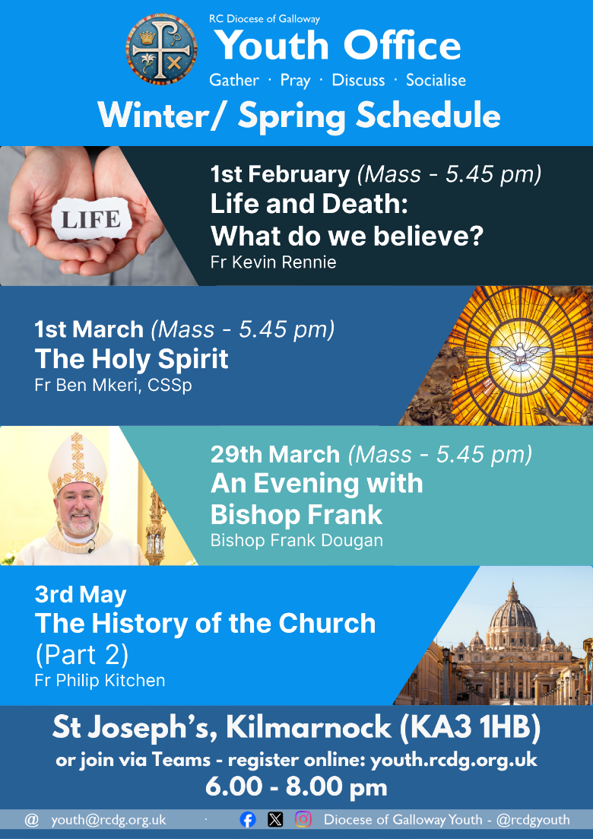
YOUNG ADULTS EVENINGS RETURN: Our Young Adults Evenings resume on Sunday 1st February when Fr Kevin will be speaking on “Life and Death: What do we believe.” We can’t wait to start our talks again – and we’d love for you to join us too! Are you aged S5-30? Join us in person or online when we start again in February! To join us online: to hear the talk, take part in the discussion, and ask questions, just go to our website and click on ‘Online Participation’ to register and we’ll send you a link ahead of each evening.
SUPPORT OUR WORK
These products are available to everyone – not just those who’ve attended events or are youth or young adults themselves –
and by buying Youth Office products you’re helping support our work.
ONLINE STORE: Our online store is open all year round, whether you’re looking for some stationery, a new mug for work or home, pens or a gift for someone. We’re regularly updating our selection, go to https://youth.rcdg.org.uk/shop to see what’s on offer.
JOIN THE 200 CLUB: Join the 40+ members who’ve already become part of the Youth Office 200 Club and help support our work while being in with a chance of winning cash prizes. For only £5 per month you can join the Youth Office’s 200 Club and be in with a chance to winning monthly cash prizes: 20%, 10% and 2 x 5% of that month’s draw. Join the growing number of people from across the Diocese and beyond who are helping support our work, and taking home cash prizes at the same time. For details, and to register, go to: youth.rcdg.org.uk/200-club or email us for a registration form.
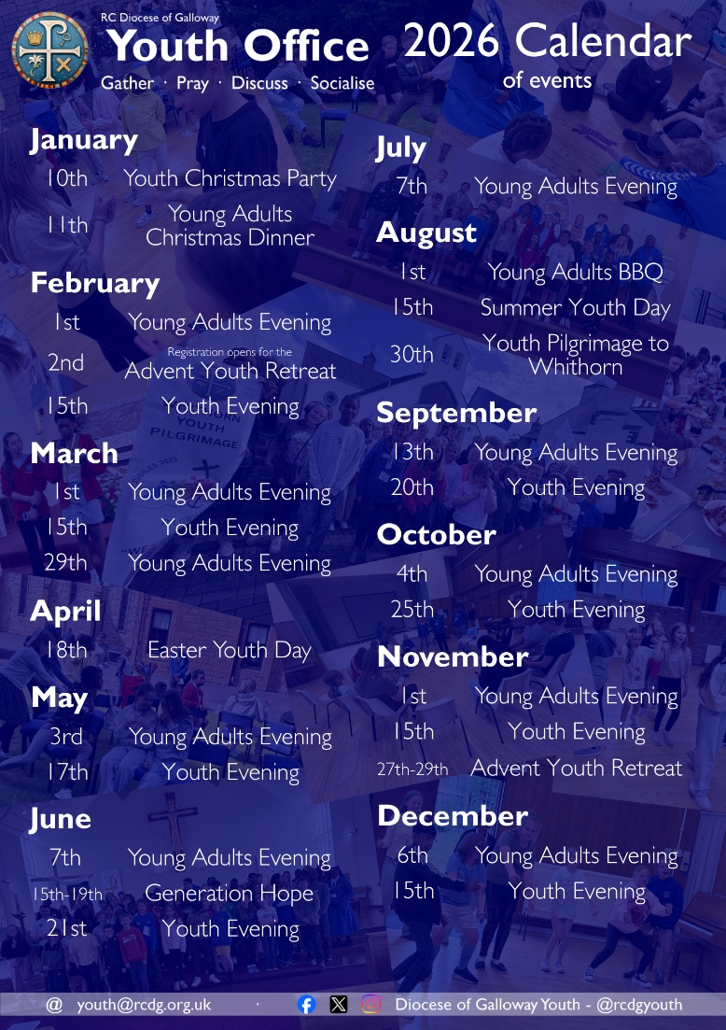
The winning numbers from the December draw: 1st – 28, 2nd – 15, 3rd & 4th – 31 & 22. All winners have been contacted.

