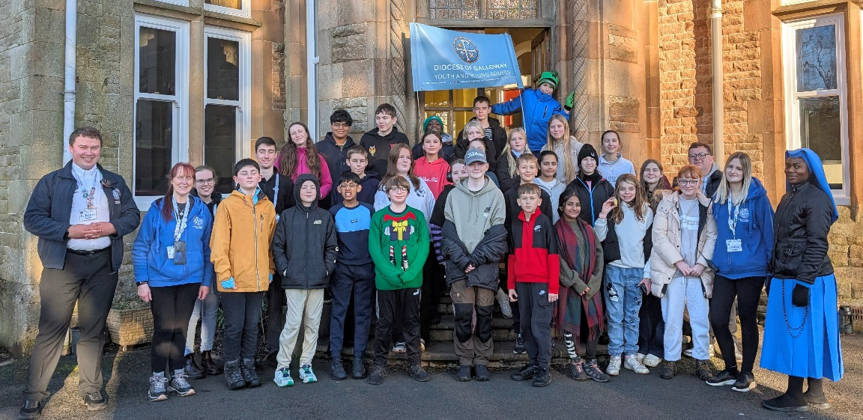

GALLOWAY YOUTH NEWSLETTER
DECEMBER 2025
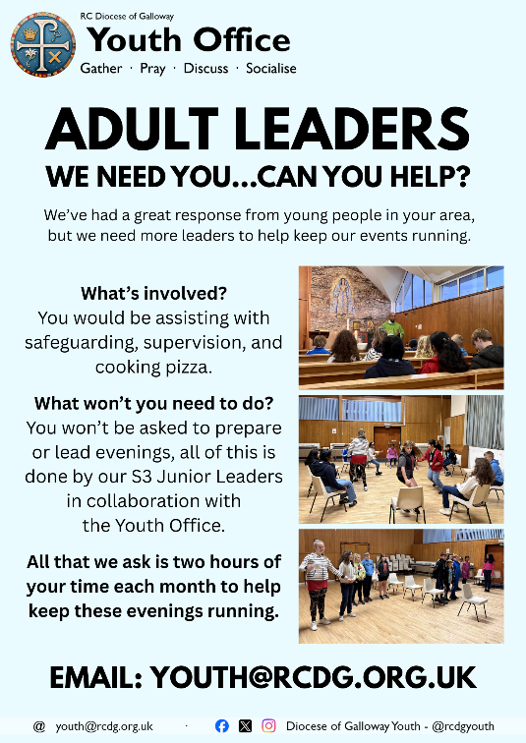
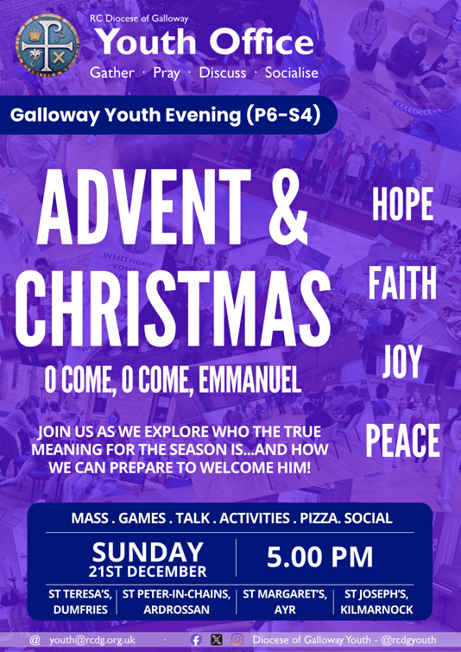

ADVENT YOUTH RETREAT: Over the first weekend of Advent, from 28th-30th November, twenty-nine young people from across the Diocese took part in our first Advent Youth Retreat at Gowanbank SU Centre. Over the course of the weekend, young people took part in a range of different outdoor activities including: tree climbing, archery, and nightline; as well as different games facilitated by the Youth Office team. All of these were interspersed with times of reflection, prayer, and Mass: including Mass with Bishop Frank and a time of Adoration with Penance on the Saturday evening. All of the young people had a fantastic time – with many expressing a strong desire to return next year. We’re grateful to the team at Gowanbank who supported us in making the weekend such a success, as well as to all of the Youth Office volunteers who assisted as residential and day leaders. SAVE THE DATE FOR 2026! 27th - 29th November 2026, more details in the New Year. Registration opens late January.
ADVENT & CHRISTMAS: YOUTH EVENING: The last of our monthly Youth Evenings for P6-S4 takes place on Sunday 21st December. This month we’ll be reflecting on the theme of ‘Advent & Christmas’ and how we can prepare to welcome Christ this Christmas. We’ll have our usual selection of fun, games, and activities all led by our Junior Leaders. The evening begins with Mass at 5.00 pm before continuing in the hall at 5.30 pm in all four clusters: St Margaret’s Cathedral, Ayr; St Joseph’s Church, Kilmarnock; St Peter-in-Chains Church, Ardrossan; St Teresa’s Church, Dumfries.
Haven’t been to a Youth Evening before? Fill in a Consent Form online, go to: youth.rcdg.org.uk. There is no charge to take part in the Youth Evenings.
CHRISTMAS YOUTH DAY – SATURDAY 10TH JANUARY: Our Christmas Youth Day for P6-S4 takes place on Saturday 10th January from 11.00 am – 4.00 pm in St Joseph’s, Kilmarnock. Join us for a fantastic day of games, activities, talks and food, all led by our S3 Junior Leaders. We’ll be joined by young people from across the Diocese, with free transport available from all four clusters as we gather to celebrate Christmas as Galloway Youth. The event is free of charge, but please scan the QR code or go to our website to register and to book your place on our transport (if required).

ADULT LEADERS – WE NEED YOU: To continue to support the running and growth of our monthly Youth Evenings particularly in St Andrew’s Deanery (Dumfries and Galloway) we need more adult leaders. What does an adult leader do? Our adult leaders are responsible for supervision, safeguarding, and cooking the pizza. You don’t have to prepare anything in advance, and you don’t have to run anything on the night – all of this is done by our S3 Junior Leaders supported by the Youth Office team. No experience is necessary, and full Safeguarding Training will be provided. All that we need you to do is to attend to supervise and to cook. Evenings normally take place from 5.00-7.00 pm on the third Sunday of each month. Could you help? Email youth@rcdg.org.uk for details and to register.
THANK YOU FOR YOUR SUPPORT: We’re extremely grateful to everyone who has helped support our ministry this year, whether by volunteering as a Junior or Adult Leader, by supporting our 200 Club and helping to ensure equal opportunities for all young people to participate, by praying for our work and offering us your support spiritually, or by coming along to an event. In 2025, we’ve reached over 200 young people, with over 500 individual attendances at events – and we can’t wait to reach even more in 2026.
We’ve a fantastic range of events planned for next year, and whether you’ve joined us this year or haven’t yet been to an event, we’d love to welcome you – so why not join us in 2026?
Alternatively, if you’d like to support our work, why not join our 200 Club or support our Online Store – by doing so you’ll be helping us to ensure that every young person, regardless of their background, has the opportunity to participate in events.

YOUNG ADULTS (S5-30)

YOUNG ADULTS CHRISTMAS DINNER: Following the success of our Summer BBQ, we invite all Young Adults (S5-30) to join us for our Christmas Dinner on Sunday 11th January in St Joseph’s Church Hall, Kilmarnock. Join us for a full three course meal and enjoy meeting up with Young Adults from across the Diocese, making new friends and seeing old friends again. The meal is free of charge, just scan the QR code to register or go to our website: youth.rcdg.org.uk. Free transport is available for those travelling from Dumfries.
YOUNG ADULTS SESSIONS ONLINE: We can’t wait to announce our Winter-Spring programme for 2026 and we’d love for you to be a part of it! Are you aged S5-30? Would you like to take part in our evenings but can’t make it in person? You can now register to join us online: to hear the talk, take part in the discussion, and ask questions. Just go to our website and click on ‘Online Participation’ to register and we’ll send you a link ahead of each evening.
SUPPORT OUR WORK
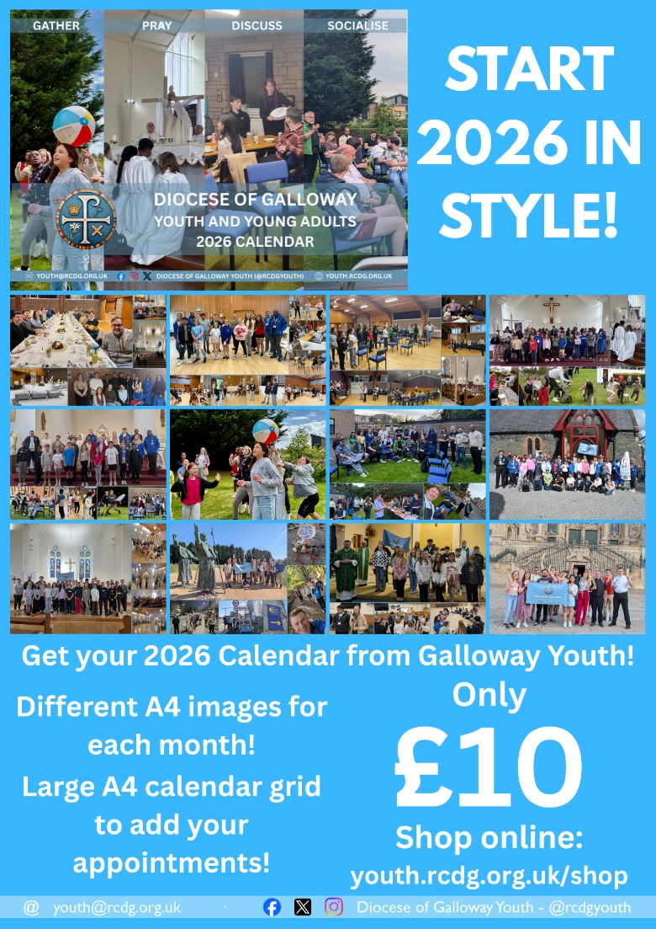
These products are available to everyone – not just those who’ve attended events or are youth or young adults themselves –
and by buying Youth Office products you’re helping support our work.

2026 CALENDAR: Our 2026 Calendar is now available to buy online or from a limited number of parishes. Journey through 2026 with Galloway Youth with a fantastic selection of images printed in A4 for each month. It also features a monthly calendar grid with ample space to add your own appointments and a full calendar of Holy Days and Youth and Young Adults events for 2026. To buy yours, go to: https://youth.rcdg.org.uk/shop. All of our products are available to anyone – not just those who’ve attended events – and by buying Youth Office products you’re helping support our work.
ONLINE STORE: Our online store is open all year round, whether your looking for some stationery, a new mug for work or home, a late Christmas Card or a gift for someone. We’re regularly updating our selection, go to https://youth.rcdg.org.uk/shop to see what’s on offer.
JOIN THE 200 CLUB: Join the 40+ members who’ve already become part of the Youth Office 200 Club and help support our work while being in with a chance of winning cash prizes. For only £5 per month you can join the Youth Office’s 200 Club and be in with a chance to winning monthly cash prizes: 20%, 10% and 2 x 5% of that month’s draw. Join the growing number of people from across the Diocese and beyond who are helping support our work, and taking home cash prizes at the same time. For details, and to register, go to: youth.rcdg.org.uk/200-club or email us for a registration form.
The winning numbers from the November draw: 1st – 28, 2nd – 9, 3rd & 4th – 23 & 24. All winners have been contacted.

FROM THE WHOLE YOUTH OFFICE TEAM, WE WISH YOU A
MERRY CHRISTMAS AND A
HAPPY NEW YEAR.

